

**Ministry of Health, Uganda**

**Integrated Human Resources Information System (iHRIS)**

***Users’ Manual for HRIS Manage***

**October 2015**

**Acknowledgement**

This document was developed with support from







By

Uganda HRIS Core Technical Team Members including Ismail Wadembere, Nobert Mijumbi, Francis Ntalazi, Martin Kiyingi, Arthur Turyahikayo, Alfred Bagenda, Michael Webba, Juliana Logose, Teddy Ndagire, John Nsubuga, Dennis Kibiye, and Louis Tugume

List of Abbreviations and Acronyms

CD : Compact Disk

CSV : Comma Separated Values

DHO : District Health Officer

DVD : Digital Video Disk

HMIS : Health Management Information System

HR : Human Resource

HRHIS : Human Resource for Health Information System

HRIS : Human Resource Information System

HRM : Human Resource Management

iHRIS : Integrated Human Resource Information System

IPPS : Integrated Personnel and Payroll System

IT : Information Technology

LAN : Local Area Network

MOH : Ministry of Health

OPEN MRS : OPEN Medical Records System

PPO : Principal Personal Officer

UCP : Uganda Capacity Program

UHSSP : Uganda Health Systems Strengthening Project

USAID : United States Agency for International Development

WB : World Bank

WHO : World Health Organization

Table of Contents

1 Introduction 1

1.1 Background 1

1.2 Accessing HRIS Manage 1

1.2.1 Accessing the system on a computer: 1

1.2.2 Accessing the system on a shared network 1

1.3 User Access 2

1.3.1 User Roles 2

1.3.2 Log in 3

1.3.3 Change Your Password 3

1.3.4 Retrieve a Forgotten Password 4

1.3.5 Log Out 5

1.4 Administer Users 5

1.4.1 Add a User 5

1.4.2 Self Service 6

1.4.3 Update a User 7

1.5 Component 8

2 Manage People 8

2.1 Add Person 8

2.2 Add Individual Information 10

2.2.1 Set Position 10

2.2.2 Changing position 11

2.2.3 Creating and setting position 12

2.2.4 Demographic and Identification 12

2.2.5 Add Passport Photo and Resume 13

2.2.6 Add Accommodation Information 13

2.3 Add Contact Information 14

2.4 Family And Next of Kin Information 14

2.5 Add Position Information 15

2.5.1 Add a Benefit/Allowance or Special Payment 15

2.5.2 Record a Departure 15

2.5.3 Record a Position Change 16

2.5.4 Record a Salary Change 17

2.6 Bank Details 17

2.6.1 Add Bank Details 17

2.6.2 Add Loan Details 17

2.7 Add Registration and Competencies 18

2.7.1 Add Registration 18

2.7.2 Language Proficiency, other Competencies and competency evaluation 18

2.8 Add Appraisal Information 18

2.9 Add Disciplinary Actions 19

2.10 Leave Management 19

2.10.1 Leave Allowance Information 20

2.11 Add Workplace Accidents 20

2.12 Add an Application 21

2.12.1 Add Application 21

2.12.2 Log Interview Details 21

2.12.3 Log Hiring Decision 22

2.13 Add Employee History 22

2.13.1 Enter Employment History 22

2.13.2 Enter Education History 23

2.14 Add Referee Information 24

2.15 Add Notes 25

2.16 Add Record Status 25

2.17 Scanned Records 26

2.18 File Tracking 26

3 Search Records 27

3.1 Search People 27

3.2 Search Positions 28

3.3 Recent Changes 29

4 Reports 30

4.1 Tabular report formats 31

Before exporting to Excel, use the Cross Tab button to choose the way you wish to select fields to display. 33

4.2 Graphical Report Formats 33

4.3 Different reports 34

4.3.1 Staff Reports 35

4.3.2 Training reports: 35

4.3.3 Position Reports 35

4.3.4 Facility Reports 36

4.3.5 Search Reports 36

4.4 Report Views 36

4.4.1 Creating and Editing report views 36

5 Administer Database 39

5.1 Geographical Areas 40

5.2 Add a Country 40

5.3 Add a Region 40

5.4 Add a District 41

5.5 Add a County or Sub-county 42

5.6 Add a Currency 43

5.7 Organization Lists 44

5.7.1 Add a Facility Type 44

5.7.2 Add an Office or Facility Name 45

5.7.3 Add a Department 47

5.7.4 Add a Registration Council 47

5.8 Create Training Information/Mentorship information 48

5.8.1 Add Training Type 48

5.8.2 Add One Training Type 49

5.8.3 Add Program Sponsor 49

5.8.4 Add Venue 50

5.8.5 Add Area of Mentorship 50

5.9 Add an Education Type/Level 51

5.10 Add Qualification 51

5.11 Add a Language 52

5.12 Add a Competency Type 53

5.13 Add a Competency 54

5.14 Add a Competency Evaluation 56

5.15 Add an Identification Type 56

5.16 Add a Benefit/Allowance Type 57

5.17 Add a Marital Status 58

5.18 Add a Reason for Departure 59

5.19 Create a Job Structure 59

5.19.1 Add Cadres 60

5.19.2 Add Job Classifications 61

5.19.3 Add Salary Scale/Grades 62

5.19.4 Add Jobs 63

5.20 Administer Positions 64

5.20.1 Add Salary Sources 64

5.20.2 Add Position Types 65

5.20.3 Add Positions 66

5.20.4 Edit a Position 68

5.20.5 Discontinue a Position 70

6 HRIS Frequently asked Questions 72

# Introduction

## Background

Integrated Human Resources Information System (iHRIS) is a management tool that enables an organization to design and manage a comprehensive human resources strategy. iHRIS has five core modules: iHRIS Qualify for health workforce registration and licensing, iHRIS Manage for human resource management, iHRIS Train for managing pre-service and in-service training, iHRIS Retain for attraction, motivation, and retention and iHRIS Plan for workforce planning and projections.

HRIS Manage helps an organization manage its workforce more effectively and efficiently. Using the system, the Human Resource (HR) professionals can create a centralized information base on all human resource management aspects such as standard titles, job classifications and job descriptions spreading over geographic locations, offices, and facilities.

HR staff can solicit job applications for open positions, assign employees to fill positions and maintain a searchable database of all employees, their identifying information and their qualifications. Managers can track each employee's history with the organization, including their position and salary histories, and record the reason for departure when the employee leaves.

HRIS Manage’s primary role is to manage workers employed in a ministry, local government (district), hospital, non-government organization, or a private organization. A decision maker within the organization can analyze this data to answer key human resource management and policy questions, such as:

* Are employees deployed in positions that match their qualifications and education?
* Are employees optimally deployed in locations to meet needs?
* How many workers need to be recruited to fulfill anticipated vacancies?
* Are pay rates equitable across similar jobs?
* Are employees being promoted in alignment with competencies?
* What are the reasons for employee attrition?

## Accessing HRIS Manage

HRIS is a database management system which can be accessed on a computer or a shared network.

### Accessing the system on a computer:

To access this system on your computer, open a web browser (e.g. Mozilla Firefox, internet explorer) and use the web interface available at: [hris.health.go.ug](http://hris.health.go.ug/).

### Accessing the system on a shared network

When accessing HRIS on the network, you need the address of the computer where HRIS is installed. This could be on the internet or local area network (LAN).

For the districts, the system is accessed on LAN by typing [10.42.43.1](http://10.42.43.1) or [10.42.0.1](http://10.42.0.1) in the web browser (e.g. Mozilla Firefox, internet explorer). For the internet, type hris followed by the name of the district e.g. hris.namutumba or type the IP address of the district

For central access at the MoH which is just for viewing go to [hris.health.go.ug](http://hris.health.go.ug) select the districts or hospital of interest by name and login.

Select the database of interest to you (see figure below)

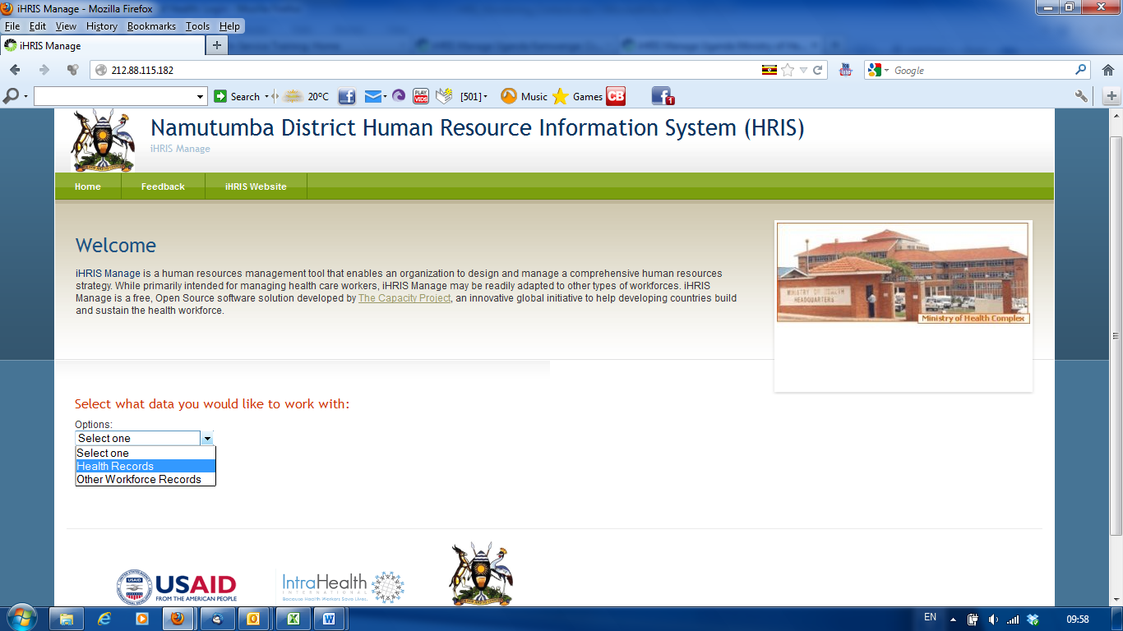

## User Access

### User Roles

Seven user roles can be assigned in HRIS Manage. The user role limits the activities that the person can perform in the system and helps enforce data quality and management protocols.

* **Administrator:** allows access to all system functions and ensures that the system is functional. The Administrator can view any record and perform any action in the system in addition to managing user accounts.
* **HR Manager:** manages all system data and ensuring that data is complete, correct and up to date. The HR Manager defines reports and analyzes data for HR decisions. In addition, the HR Manager is the only role other than the Administrator who can configure (setup for a particular purpose) the database.
* **HR Staff:** adds, views and updates data in the system, as well as viewing reports. The integrity of the data entered by HR Staff is ensured by the HR Manager.
* **Executive Manager**: can view records, job applications and access all reports in the system. This role does not allow making of changes to the system information
* **Geographical / Facility Access:** access facility or geographical location records.
* **Training Manager:** adds and or updates training information.
* **Self-service:** views personal records and raise any concerns to the HR manager.

### Log in

To gain access to the system, you must have a user account. Type your user name and password and click **login** (see figure below)

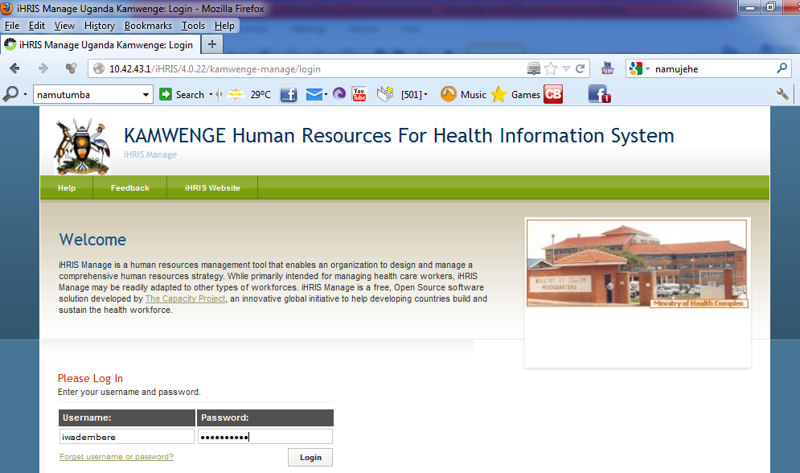

*Note: If you do not have a user account, contact your System Administrator.*

### Change Your Password

At any time, you can change your password for logging into the system. The Change Password form opens.

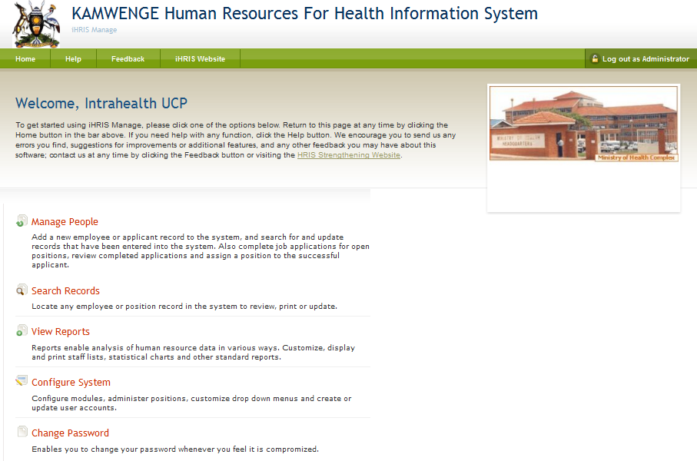

Click here to change password.

Enter your **Old Password** (current password).   
Enter the desired **New Password**.   
Re-enter the new password under **Confirm New Password** to confirm it.   
Click **Change Password.** This will reset to the new password.

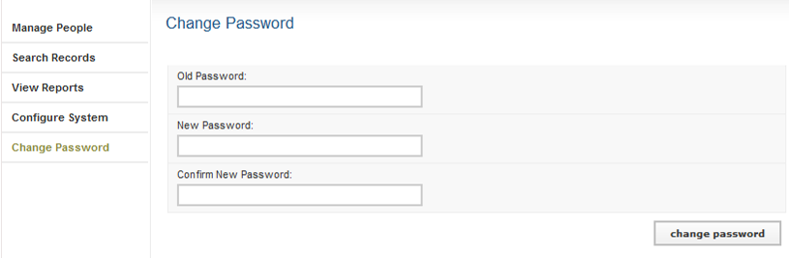

### Retrieve a Forgotten Password

Contact your system administrator in case you have forgotten your password or username

**OR**

From the Log In page, click **Forgot username or password?**

To reset the password, enter your **Username** in the box next to "Reset Password" and click the **Reset button**. The system will email your new password to you

To recover your username, enter your **Email Address** in the box next to "Display Username" and click the View button. The system will display your username.   
  
Click the link to **Return to login page** and log in as normal

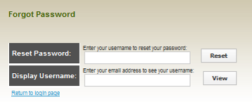

### Log Out

When you are finished working in the system, log out to prevent any unauthorized person from accessing the system.

In the upper left corner on any page, click Log out (next to the padlock).

[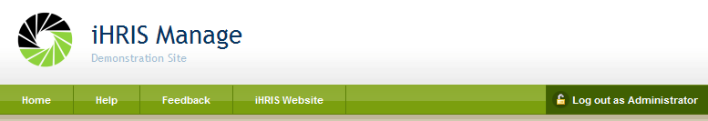](http://open.intrahealth.org/ihrismanual/file_logout.html)

The Welcome page appears. You will have to re-enter your username and password to regain access to the system afresh.

## Administer Users

Click **Administer Users** under **Configure System** to create, update and disable user accounts to enforce secure access to the system. Only the System Administrator can add and update user accounts.

### Add a User

In order to allow a user to access the system, the System Administrator must create a user account for the person, with a unique username and password. Each user is assigned a role, which determines the actions that the user can perform in the system.

On the Home page or left menu, click Configure System. Click Administer Users.

[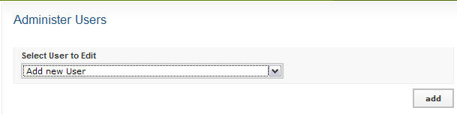](http://open.intrahealth.org/ihrismanual/file_adduser1.html)  
  
Select **Add New User** from the dropdown menu and click the Add button

[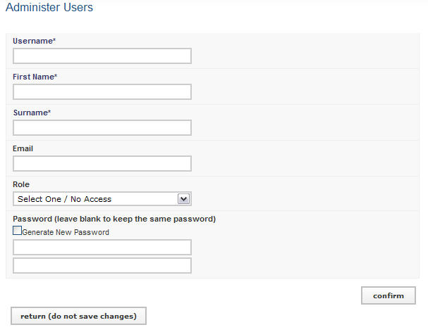](http://open.intrahealth.org/ihrismanual/file_adduser2.html)

Enter a **Username** for the user: one word with no special characters (letters and numbers only).   
  
Enter the **First Name** and **Surname** of the user.   
Enter an **Email** for the user, if known (optional).   
Select the **Role** of the user (see below for roles). If no role is selected, the user will be disabled and cannot access the system in any capacity.   
  
Select the option to randomly **Generate New Password** or enter a **Password** for the user. If the password is entered, re-enter it to confirm. The two passwords must match.   
  
**Click Confirm** and verify that the account entered is correct. If it is not correct, click Edit to change it. If it is, click Save to save it.

If an email address was entered, an email message will be sent to the user with the username and password. Otherwise, you will have to provide the user with the username and password.

### Self Service

A self-service account can be created for each staff whose details have been entered in systems so that they can login to view their details only.

Search for person, display their details and go to the last section – **self-service** and click on **Add User Account** get the window below

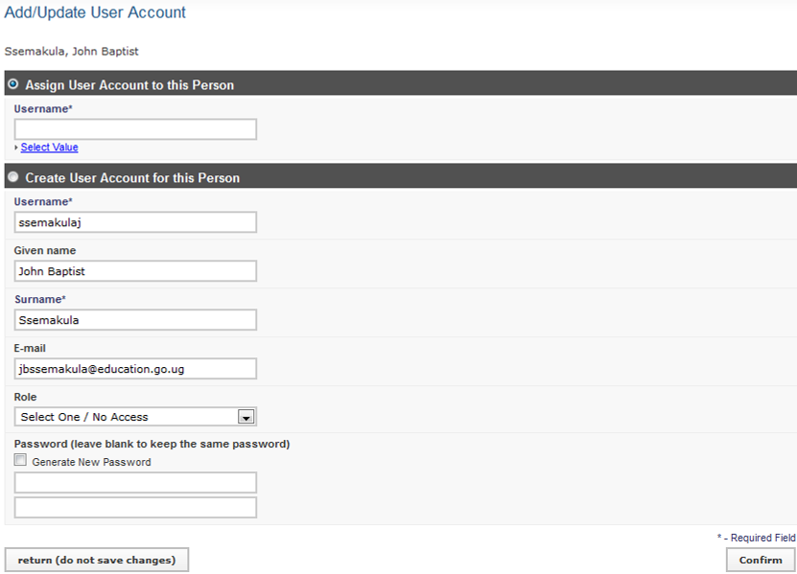

Enter the data in the appropriate fields. Click **Confirm,** review the information,and **save**

### Update a User

To change user information, click **Configure System** and then Click **Administer Users.**   
From the drop down menu select the user account to change.

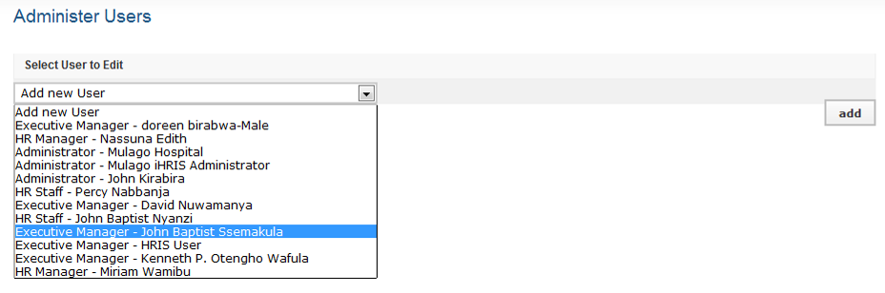

Update the user account.

*Note: Usernames and passwords may also be changed.*  *If a user no longer has access to the system, the account can be disabled.*

## Component

To get started using iHRIS Manage, please click one of the options below

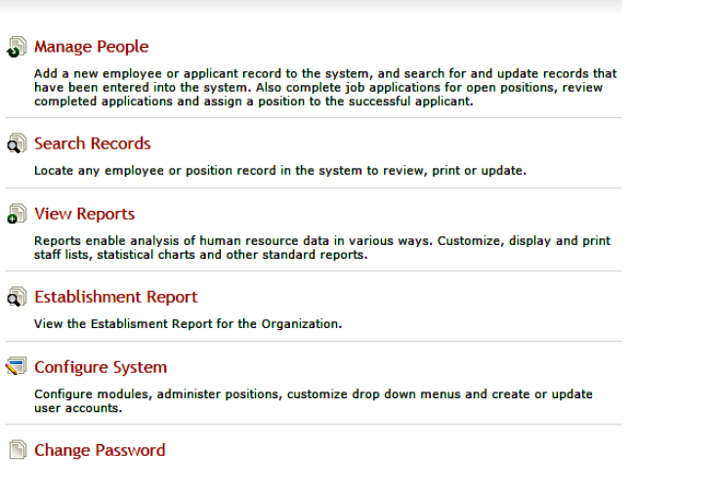

# Manage People

Click Manage People to add a new employee or review applicant.

## Add Person

This sub module enables to track a person in the database, whether an employee or a job applicant, add a record for that person by clicking the Add Person option.

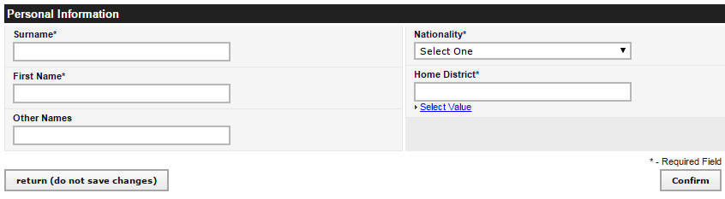

Enter the person's **Surname**, **First Name** and any **Other Names** in the appropriate fields. Select the person's **Nationality** from the dropdown menu. Click on “**Select Value**” to choose the name of the person's country, region, district, sub-county of residence under **Residence**.

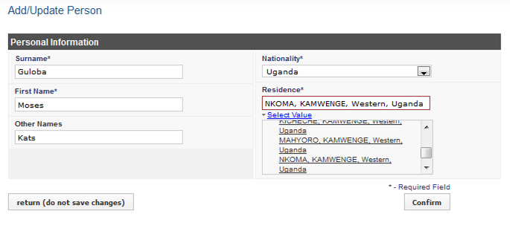  
  
Click Confirm, the data that you just entered will appear.

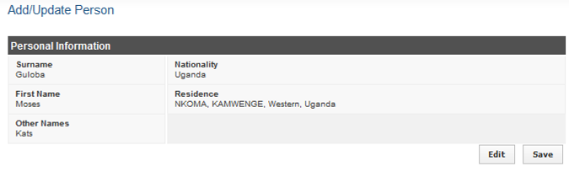

Confirm that the information entered is correct. If it is not correct, click Edit to change it. If it is, click Save to save it.

The person's new record opens with options to add additional information divided into sections.

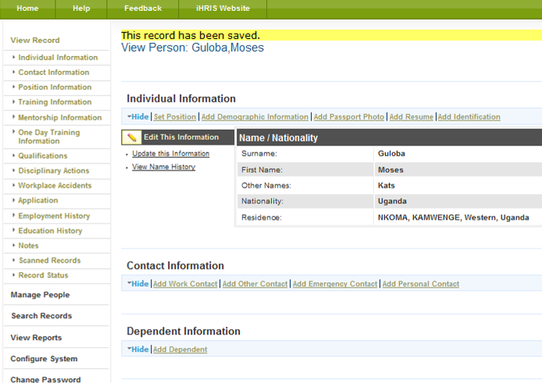  
*Note that you can click the Hide/Expand option at the top of any section to hide or display that section. You can edit or update a person's record at any time by searching for the record*

## Add Individual Information

### Set Position

The employee's record displays immediately after an employee has been added to the system. The next step is to set the position that the employee will fill. Until the position has been set, the employee will not appear in any current employee lists.

**Click set position** tab under the "Individual Information" section.

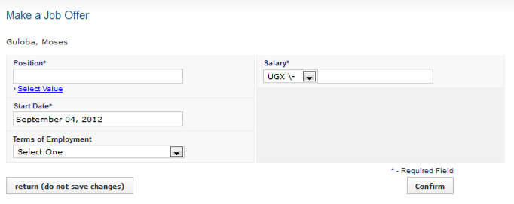

Click **Select Value** under position, select the facility/office of interested, and choose the appropriate position.

*Note*: The employee's position must have been created in the system, in case the position is not in the system *see administer database section* to create the position or user creating and offering position below.

Set the start date, terms of employment, and enter the salary value

Click **Confirm,** review the information,and **save**

### Changing position

If the person has a position already, clicking set position, opens the window that allows offering a new position to a person, **Select Existing Position** if the position existing.

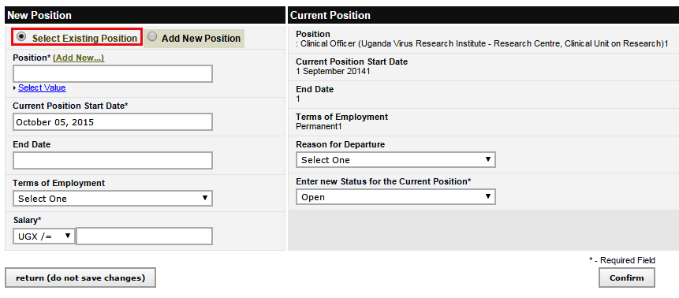

Select position, set the start date, terms of employment, and enter the salary value

Click **Confirm,** review the information,and **save**

### Creating and setting position

If the position does not exist in the facility, the create one and immediately offer it to person,

**Select Add new position** option

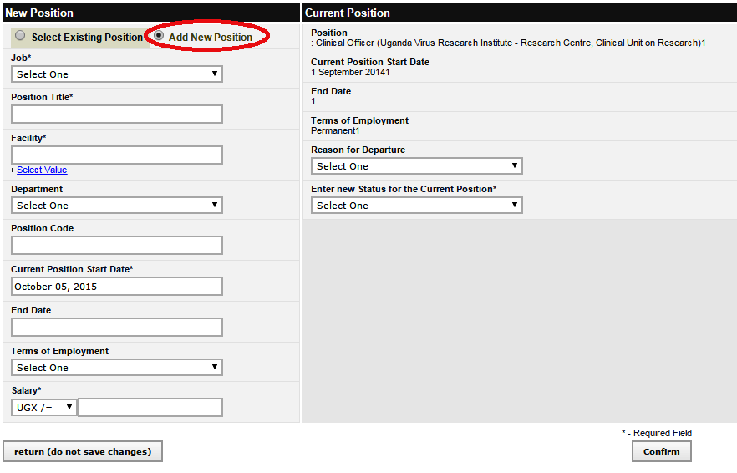

Select job under which position falls, type the position title, set the start date, terms of employment, and enter the salary value

Click **Confirm,** review the information,and **save**

### Demographic and Identification

Repeat the same procedure as in setting the position to add demographic information and identification

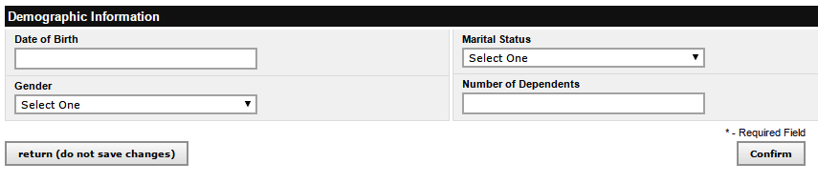

Note:

1. Your organization may require one or more identifications from employees and job applicants. Add this identification information to the person's record. Multiple identifications may be added for a single person e.g. passport number, computer number, file number, account number, etc.
2. Add demographic information about the employee for reporting purposes. Demographic information includes date of birth, gender, marital status and number of dependents. All demographic information is optional.

### Add Passport Photo and Resume

Click on add passport photo

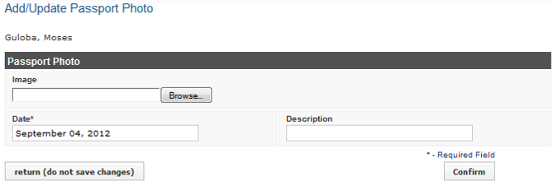

Under image click Browse and locate the passport photo of the individual. Select the photo and click open. You can write description of the photo.

Click **Confirm,** review the information,and **save**

Repeat the procedure of adding passport photo to add resume.

### Add Accommodation Information

Click on add Accommodation Information to get the window below

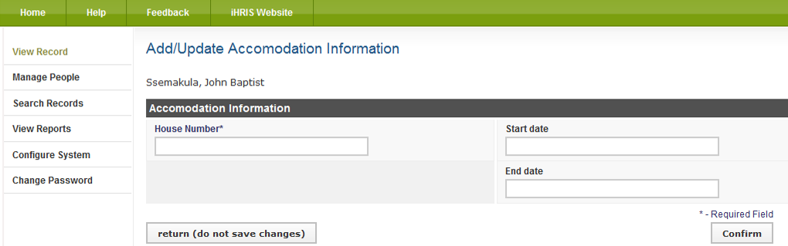

Enter the person's **House number, start date,** and **end date** in the appropriate fields.

Click **Confirm,** review the information,and **save**

## Add Contact Information

For each person in the system, whether an employee or a job applicant, four types of contact information may be added: personal, or home, contact; work contact; emergency contact; and other contact. Only one contact may be added for each type. Contact information may be added at any time after the record is created. All contact fields are optional.

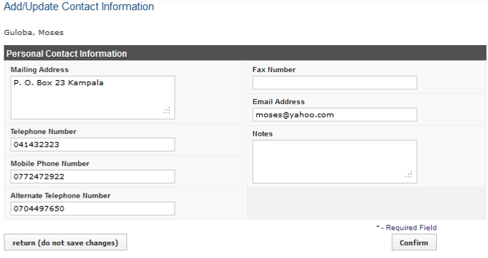

Click **Confirm,** review the information,and **save**

## Family And Next of Kin Information

Click on **Add Spouse Information tab** to add spouse’s Information.

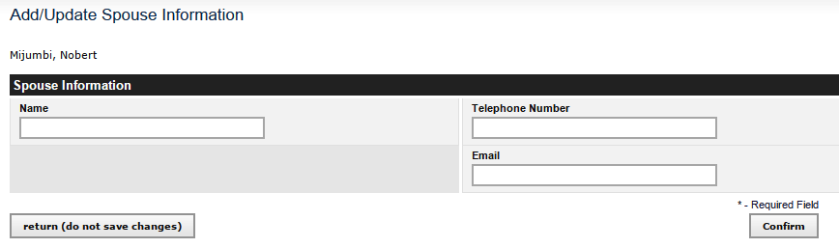

Click **Confirm,** review the information,and **save**

Repeat the same procedure as in **Add Spouse Information** to add Next of, Father and Mother Information

## Add Position Information

### Add a Benefit/Allowance or Special Payment

If an employee receives an irregular or one-time benefit or special payment - such as an allowance, travel advance or relocation payment - in addition to the regular salary, that can be noted in the employee's record under the employee's Position Information.

Click **Add Benefit/Special Payment**.

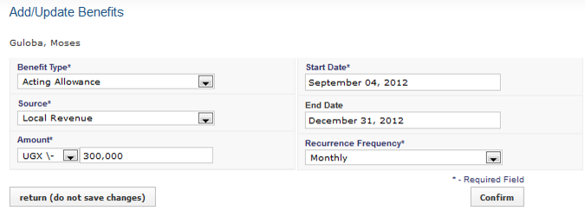

**Note:** Frequency of the payment: once, weekly, monthly or yearly. If the frequency is set to "once," the start date and end date should be the same or the end date may not be entered.   
  
Click Confirm and confirm that the information entered is correct. If it is not correct, click Edit to change it. If it is, click Save to save it.

For each new benefit, click **Add Benefit/Special Payment** and follow these same steps.

If any of the benefits information needs to be changed, click **Update This information** beside the incorrect benefit to edit it.

### Record a Departure

When an employee leaves the employment of the organization, the date of and reason for departure should be recorded in the employee's record. The employee will become an inactive (or "old") employee in the system, but the employee's data will still be available for historical reporting.

Under the position, click **Record a Departure**.

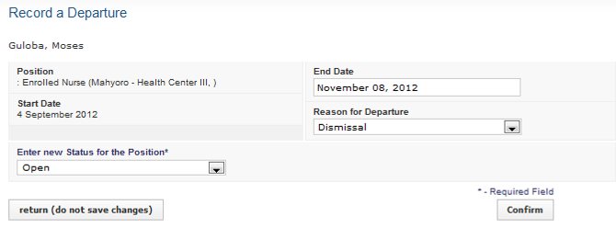

The **End Date** for employment is set to today's date by default. If that is not correct, change the date. Select the **Reason for Departure**. Select the **New Status** for the position: Open or Discontinued; if the position is marked "Open," it will be available for assignment to another employee or applicant.

Click Confirm and confirm that the information entered is correct. If it is not correct, click Edit to change it. If it is, click Save to save it.

### Record a Position Change

When an employee changes from one position to another in the organization, the position change should be recorded in the employee's record. All of the positions that the employee has held in the organization are saved to the employee's Position History, which can be reviewed at any time.

Under the position, click Change Position. The Make a Job Offer form opens, showing the current position title and start date.

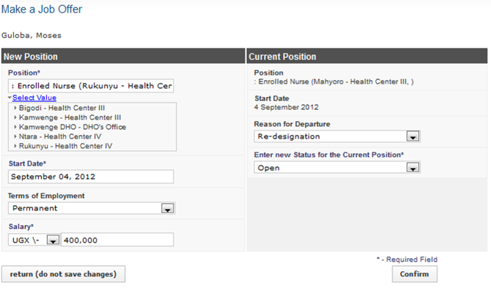

Under **select value**, choose facility and select the position title of the new **Position**.   
  
The **Start Date** for the new position is set to today's date by default. If this is not correct, change it. This will also be the end date for the employee's old position.   
  
Select the **Currency** and enter the amount of the **Salary** for the new position; this may be the same as the employee's previous salary. Under **Reason for Departure**, select the reason for the position change. Select the **New Status** for the position: Open or Discontinued; if the position is marked "Open," it will be available for assignment to another employee or applicant.   
  
Click Confirm and confirm that the information entered is correct. If it is not correct, click Edit to change it. If it is, click Save to save it.

### Record a Salary Change

If an employee's salary changes, the new salary can be updated in the employee's record. The old salary will be saved in the employee's Salary History, which may be reviewed at any time.

Repeat the same procedure as recording a departure for implementing salary change.

## Bank Details

### Add Bank Details

To add Bank Details, Click **Add Bank Details**.

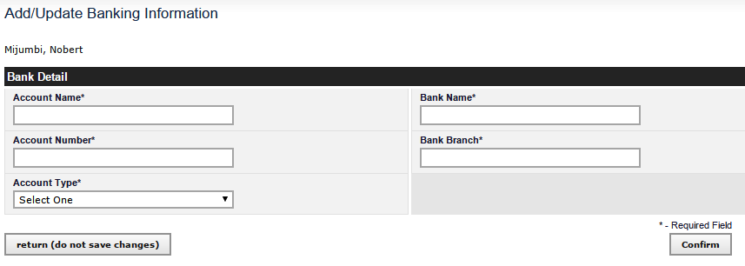

Click Confirm and confirm that the information entered is correct. If it is not, you can return to the previous page without saving the changes.

### Add Loan Details

Repeat the same procedure for adding load details.

## Add Registration and Competencies

### Add Registration

Many health workers are required to be registered or licensed by a professional council.

Click **Add Registration** under Registration and competencies

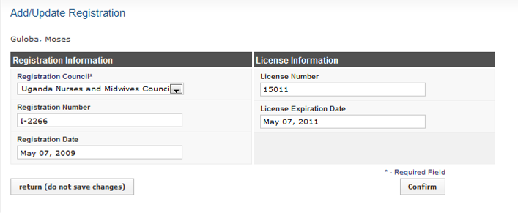

Click Confirm and confirm that the information entered is correct. If it is not correct, click Edit to change it. If it is, click Save to save it.

### Language Proficiency, other Competencies and competency evaluation

To add employee language proficiency in speaking, reading and writing each language can be recorded separately. Each competency is grouped under a broad category or competency type. Employee's competencies can be evaluated, and evaluations updated and tracked in the employee's evaluation history

Repeat the same procedure for adding registration information as indicated above.

## Add Appraisal Information

Click on add Appraisal Information to get the window below

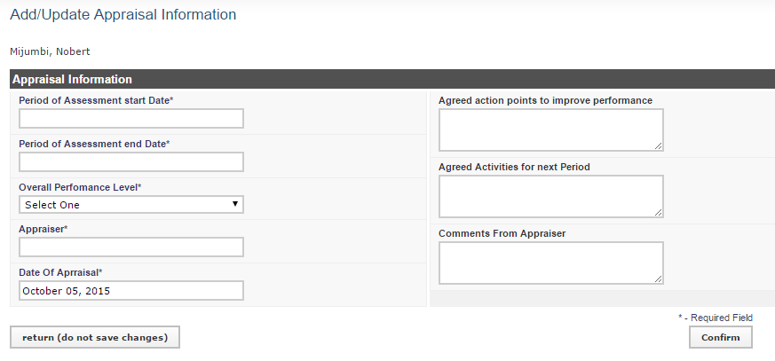

Enter the data in the appropriate fields. Click **Confirm,** review the information,and **save**

## Add Disciplinary Actions

This section takes into account the actions and reasons for any in-discipline case.

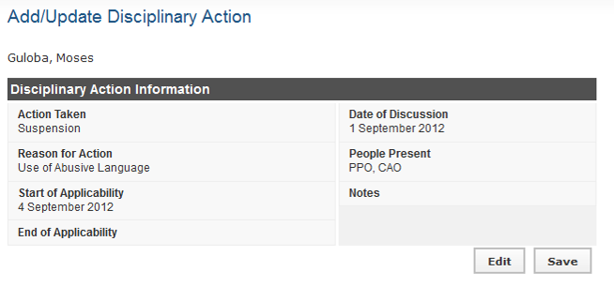

Click Confirm and confirm that the information entered is correct. If it is not correct, click Edit to change it. If it is, click Save to save it.

## Leave Management

For planning and management of leave being taken by staff, individual leave applications and leave taken is added on personal record. Under Leave Information, click on the **New leave information** or **Update This Information** to Update

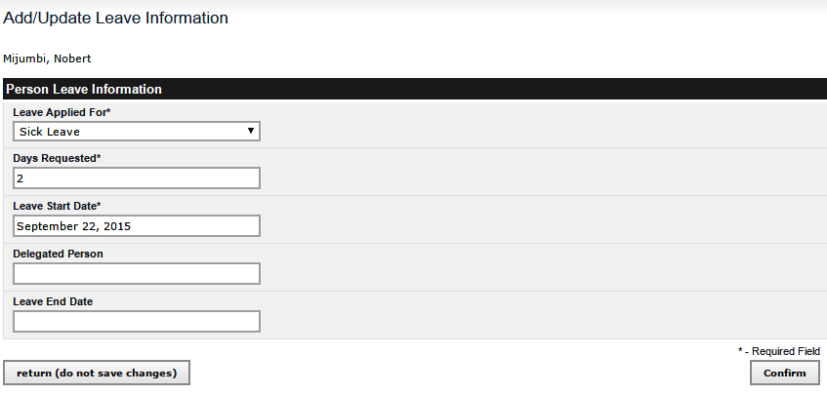

### Leave Allowance Information

The Leave Allowance Information specifies the period in which a staff is eligible to take leave. click on the **Leave Allowance Information** and **Add/Update This Information** to Update.

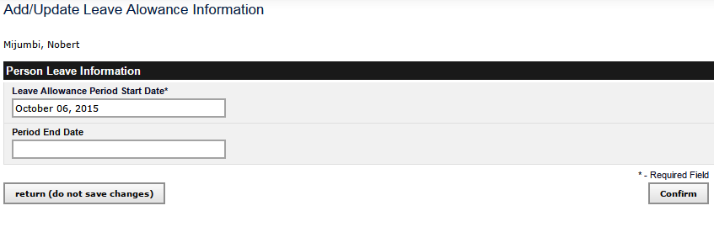

## Add Workplace Accidents

These are occupational hazards encountered in line of duty.

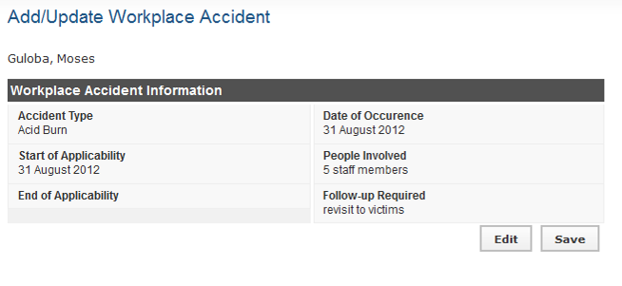

Click Confirm and confirm that the information entered is correct. If it is not correct, click Edit to change it. If it is, click Save to save it.

## Add an Application

### Add Application

An existing employee with a set position can apply for an open position on the system

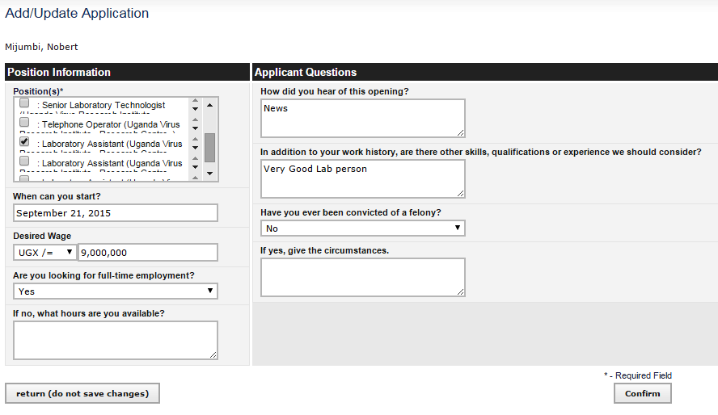

Click Confirm and confirm that the information entered is correct. If it is not correct, click Edit to change it. If it is, click Save to save it.

### Log Interview Details

While an applicant is being interviewed, details with the applicant are captured and entered into the system.

Click **Log Interview Details** to enter the names or titles of **People Conducting Interview,** any **Comments** about the interview.

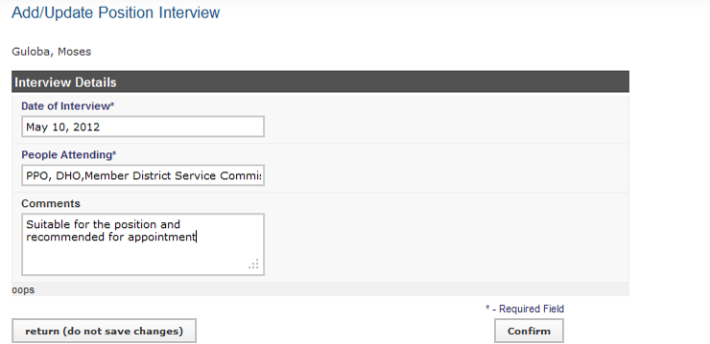  
  
Click **Confirm** and confirm that the information entered is correct. If it is not correct, click Edit to change it. If it is, click Save to save it.

### Log Hiring Decision

After the interview, the applicant is offered a job and the details are entered to confirm the job offer. E.g., the Title of the job offered and the minute number.

Click **Log Hiring Decision**

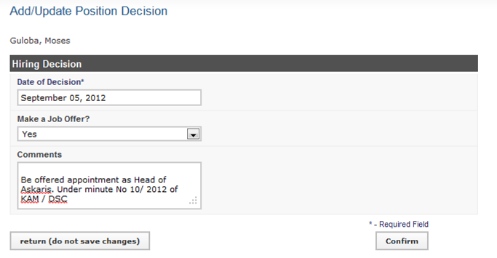

## Add Employee History

### Enter Employment History

As part of completing the job application, the applicant's employment history should be recorded. The employment history can also be added to the record of any employee of the organization.

Click **Add Employment**.

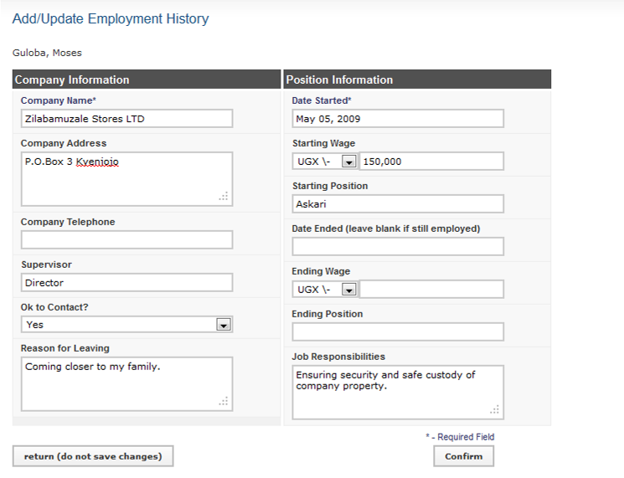

Click Confirm and confirm that the information entered is correct. If it is not correct, click Edit to change it. If it is, click Save to save it.

You can add as many previous Employment positions as there are by repeating the same procedure.

### Enter Education History

The education history can also be added to the record of any employee of the organization.

Click **Add Education.**

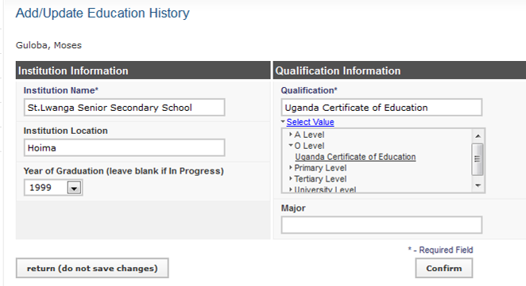

Note: Under Qualification,click **select value** and click on the desired education level to choose thequalification. if the values are not in the drop down menu, see **Administer database**.

Click Confirm and confirm that the information entered is correct. If it is not correct, click Edit to change it. If it is, click Save to save it.

The past education displays in the person's record under the "Education History" section. Click **Update This Information** beside the employer to edit any of the fields, if necessary.   
  
Repeat this process for each educational institution attended.

## Add Referee Information

The referee Information can also be added to the record of any employee of the organization.

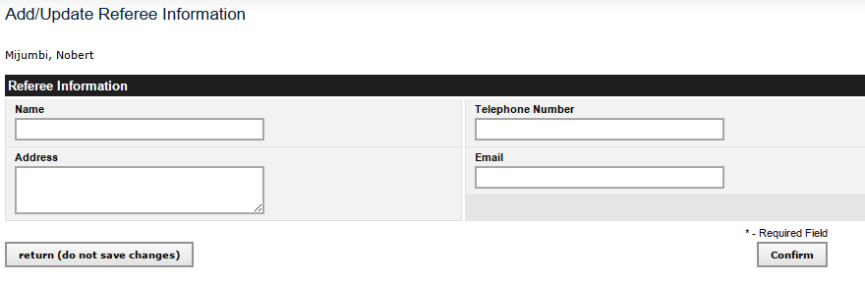

Click Confirm and confirm that the information entered is correct. If it is not correct, click Edit to change it. If it is, click Save to save it.

You can add as many references by following the same procedure**.**

## Add Notes

At any time, an HR Staff person or an HR Manager may add notes to a person's record. All notes are saved to a log and may be reviewed as necessary.

Click **Add Note.**

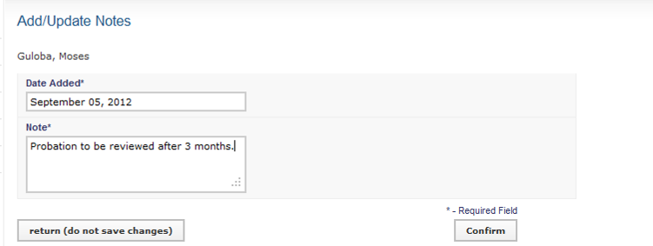

Enter a **Date Added** for the note; if no date is entered, today's date is saved by default.

All notes will appear at the bottom of the person's record under the "Notes" section. Repeat these steps to add additional notes.

## Add Record Status

Capture any information regarding the status of an employee’s record.

Click **Add / Update Record Status**

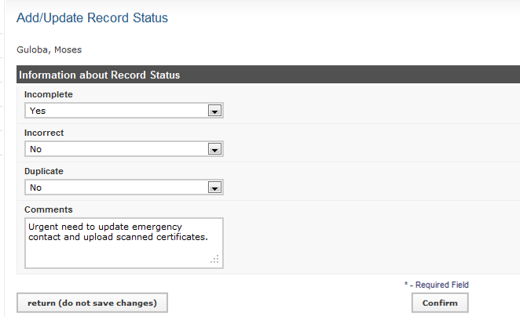

Click Confirm and confirm that the information entered is correct. If it is not correct, click Edit to change it. If it is, click Save to save it.

## Scanned Records

Scan and upload employee documents from their personal files.

Click **Add** **Scanned Document**

There are two file types that can be uploaded i.e. images (pictures, photos) and text documents (Pdf, word)

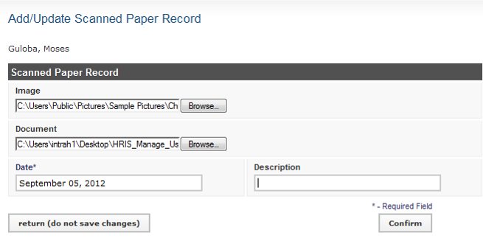

Click Confirm and confirm that the information entered is correct. If it is not correct, click Edit to change it. If it is, click Save to save it.

Note: You can add more scanned documents using the same procedure.

## File Tracking

To help track location of a staff personal file i.e. to which office the file has been taken and for what purpose, fill the file tracking information

Click on New File Movement Information to get the window below

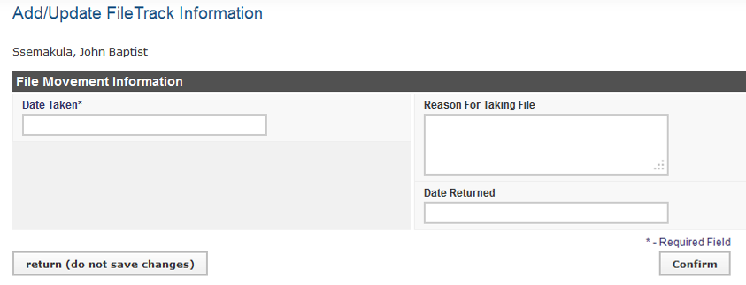

Enter the data in the appropriate fields. Click **Confirm,** review the information,and **save**

# Search Records

After entering an employee or position in the system, the record may be reviewed at any time.

Click **Search Records** to locate the record. From the record, additional information can be added or existing information can be updated.

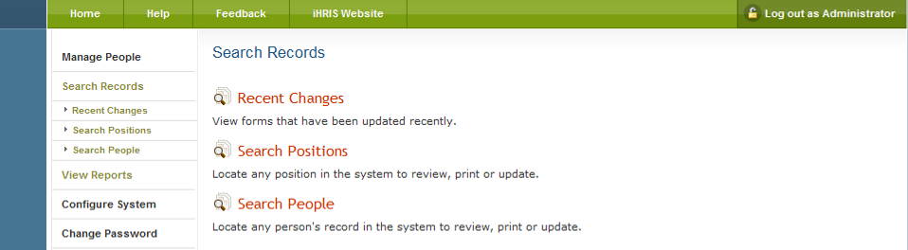

## Search People

Click **Search People.**

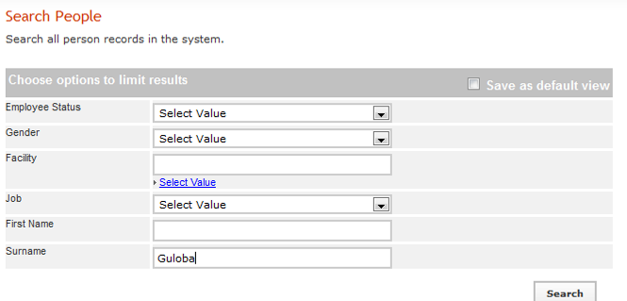  
  
Enter the person's **Surname** to find a single record or leave blank to find multiple records.   
  
Limit the search to a particular job by selecting that job title from the **Job** menu. Leave blank to search all jobs.

Limit the search to a particular facility by selecting that facility name from the **Facility** menu. Leave blank to search all facilities.   
  
Click the search button to show all matching results.

A list of matching records displays. Click the name of the person whose record you want to review.   
  
To search again, select new options from the Search form and click search.

## Search Positions

Click **Search Positions**.

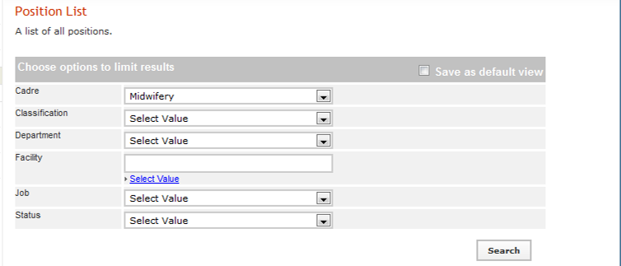

Select one of the options provided at a time to limit the search by Job**, Facility, Department, Status, Cadre** or **Classification**. If an option is not selected, all records will be searched.

Click the search button to show all matching results.

A list of matching positions displays. Click the title of the position you want to review.

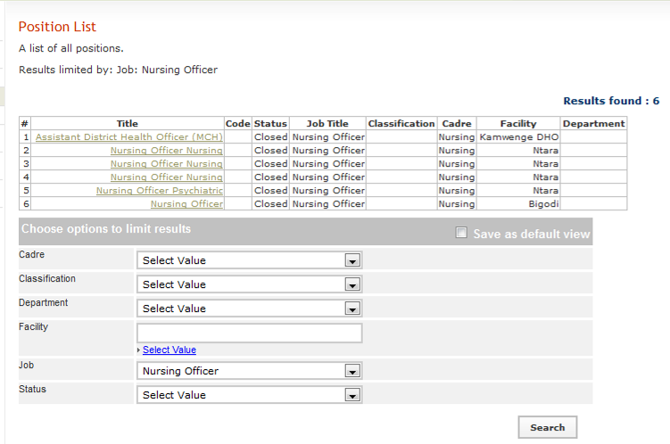

When you click the position title, the position record displays, showing all information about the position and the name of the employee currently holding the position, if any. From this screen, you can update the position information, select another position or view and update the employee's record.

To search again, select new options from the Search form and click search.

## Recent Changes

Click **Recent Changes** to view the most recent updates made to the database. To view recent changes click either Person or Position

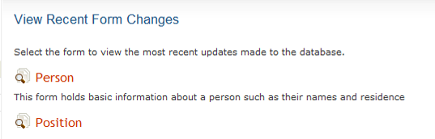

# Reports

To access any report of interest, click **View Reports.** A list of reports will appear.

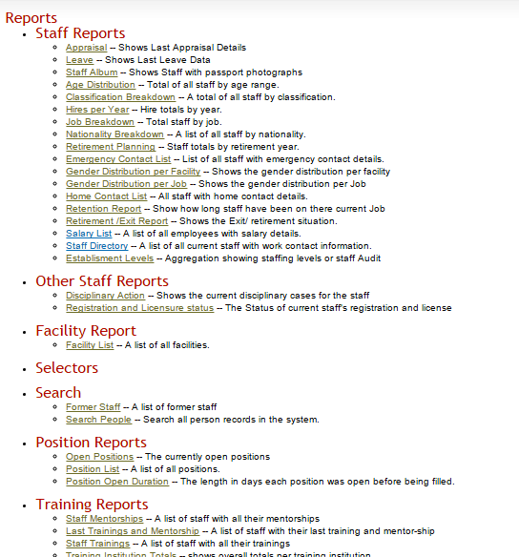

Click the desired tabular report e.g. **Staff Directory** (Staff List).

There are two types of reports i.e. Graphical and Table format.

## Tabular report formats

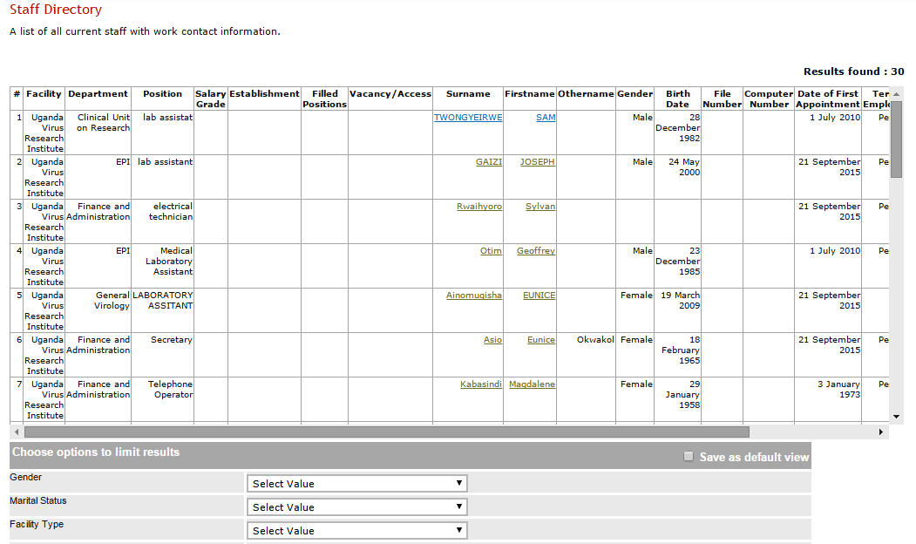

To create a pdf file of the above report, click the ***Print*** *button*

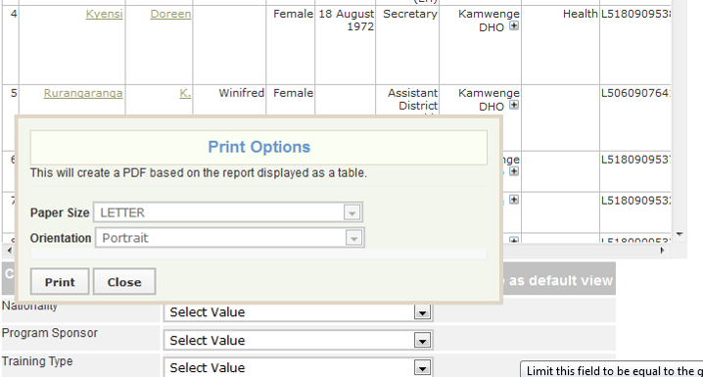

Change paper size & orientation and **Print**

To create an Excel file of the above report, click the ***Export*** *button*

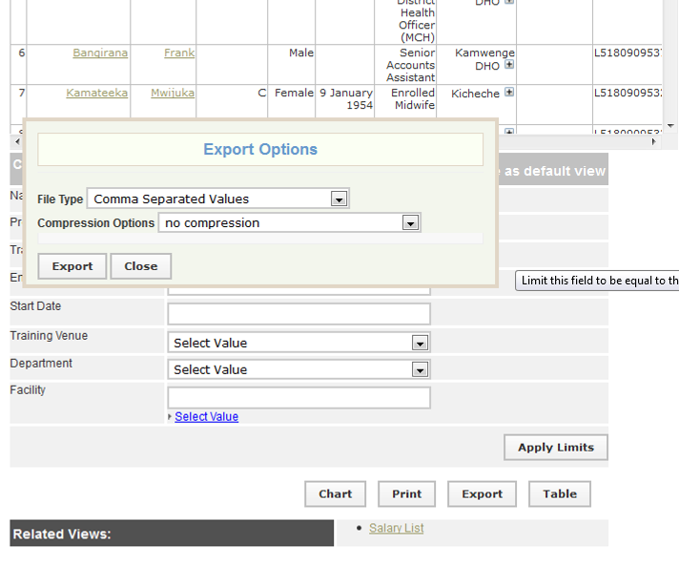

Click the **Export** button again.

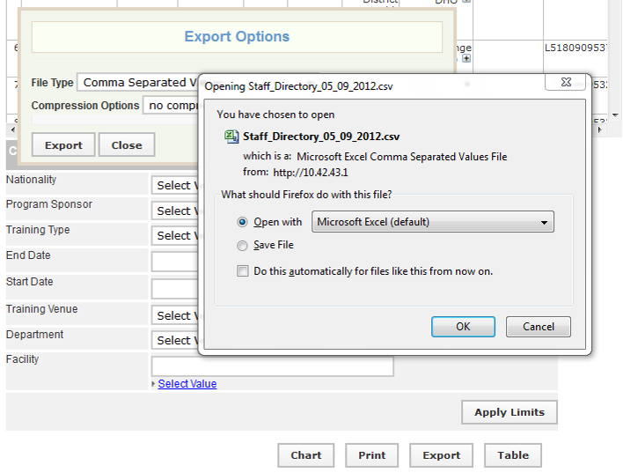

To view the report without saving, choose **open with**. Select **Save File** to save the report.

Note: This file opens or saves as * **.CSV**. To change the file format, Go to **File menu**, select **Save As,** type file name, under **save as type** choose **Excel 97-2003 workbook** from the drop down menu

## Before exporting to Excel, use the Cross Tab button to choose the way you wish to select fields to display.

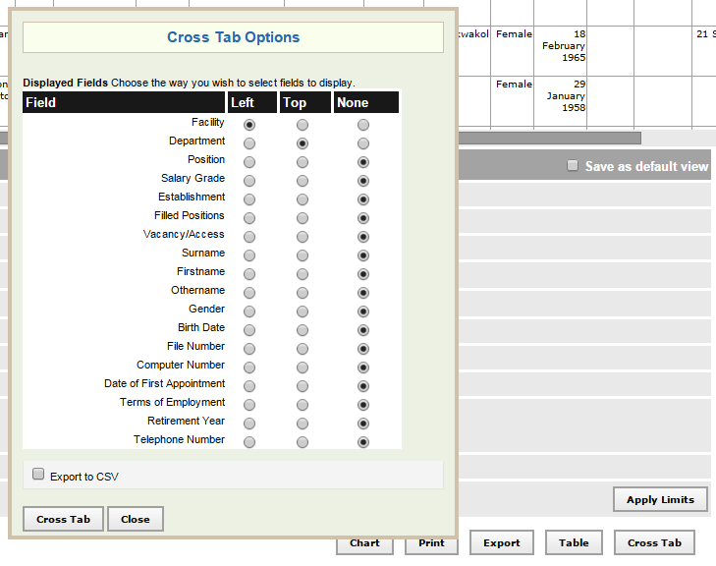

## Graphical Report Formats

Follow the above steps as used to display the tabular report format to get graphical report be clicking **Chart** button

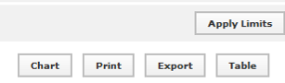

Click the Chart Button to display summary information in chart format.

Note: This button is only applicable to reports with not more than two fields where one field is numeric.

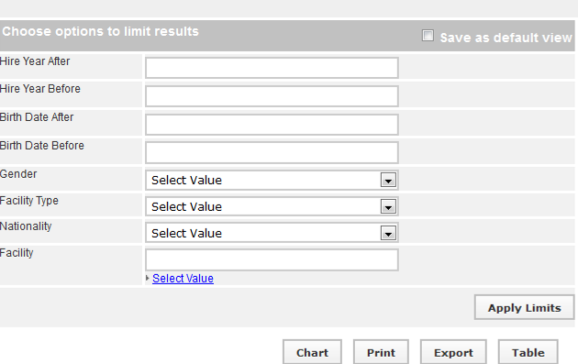

Use **Apply Limits** button to filter and narrow the search scope for the selected report.

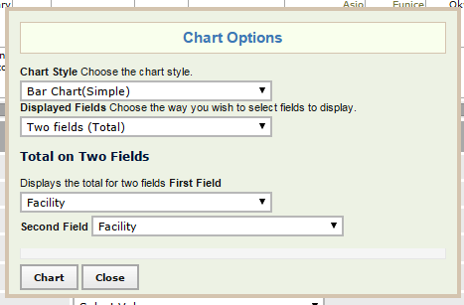

Select the desired chart style here.

Choose the desired chart format from **Chart Style** drop down menu, Choose the way you wish to select fields to display from the **Displayed Fields.**

***Note: Using the procedure above, will help to produce the necessary reports as desired by the user***

## Different reports

The following pre-defined report views are available once HRIS Manage is installed.

### Staff Reports

These reports pertain only to employees who have records in the system. The lists can be filtered by the employee's nationality, or the facility or department where the employee is located. The charts can be filtered by employee nationality or gender, or the facility or type of facility where employees are located.

* **Appraisal:** Shows Last Appraisal Details
* **Leave:** Shows Last Leave Data
* **Staff Album:** Shows Staff with passport photographs
* **Age Distribution:** Total of all staff by age range.
* **Classification Breakdown:** A total of all staff by classification.
* **Hires per Year:** Hire totals by year.
* **Job Breakdown:** Total staff by job.
* **Nationality Breakdown:** A list of all staff by nationality.
* **Retirement Planning:** Staff totals by retirement year.
* **Emergency Contact List:** List of all staff with emergency contact details.
* **Gender Distribution per Facility:** Shows the gender distribution per facility
* **Gender Distribution per Job:** Shows the gender distribution per Job
* **Home Contact List:** All staff with home contact details.
* **Retention Report:** Show how long staff have been on there current Job
* **Retirement /Exit Report**: Shows the Exit/ retirement situation.
* **Salary List:** A list of all employees with salary details.
* **Staff Directory**: A list of all current staff with work contact information.
* **Establisment Levels**: Aggregation showing staffing levels or staff Audit

### Training reports:

These reports show training and mentorship information

* **Staff Mentorships:** A list of staff with all their mentorships
* **Last Trainings and Mentorship:** A list of staff with their last training and mentor-ship
* **Staff Trainings:** A list of staff with all their trainings
* **Training Institution Totals:** shows overall totals per training institution
* **Training Type Totals:** Totals' of people trained per training type

### Position Reports

These reports pertain only to positions entered in the system. They can be filtered by job, facility and department where the position is located, position status, cadre and job classification.

* **Open Positions:** The currently open positions
* **Position List:** A list of all positions.
* **Position Open Duration:** The length in days each position was open before being filled.

### Facility Reports

These reports pertain only to offices or facilities entered in the system. They can be filtered by the facility type and by the country and district where the facility is located.

* **Facility List:** The table lists all offices and facilities.

### Search Reports

These reports enable users to search for specific employee's record by the employee's surname, status, job or facility where the employee is deployed. The same report can be accessed from the **Search Records** screen.

* **Former Staff:** A list of former staff
* **Search People:** Search all person records in the system.

## Report Views

Report views define how data are displayed in a report. Multiple report views can be created for the same report so that data may be aggregated and analyzed in various ways. For each report, data can be displayed either as a table or as a chart. The data may also be exported for further analysis, or the report may be printed.

### Creating and Editing report views

Administrators and Managers can create new report views or edit views that have already been defined. At least one report view must be defined before a report can be run. Other users may run any report view, but they cannot create new views. Creating report views requires some knowledge of the data fields used in HRIS.

*Note: Unless you understand these fields, you should not edit or delete the existing report views pre-defined in HRIS.*

To create report views, click **Configure System** under "Manage Reports” click **Report Views**.

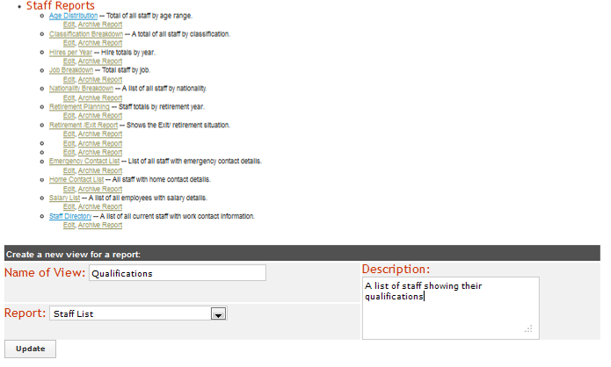

Type the name of the report view, select the affliated report, type a short description of the report view & click update

The pop up screen displaying the message ‘**successfully updated values’** click **Close**

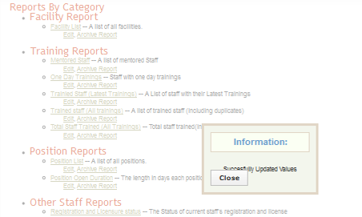

This is a pop up screen

***Note: The following steps also apply to editing an existing report view***

Locate the newly created or existing report view and click on **edit** in order to activate or edit the fields to be seen in the view respectively.

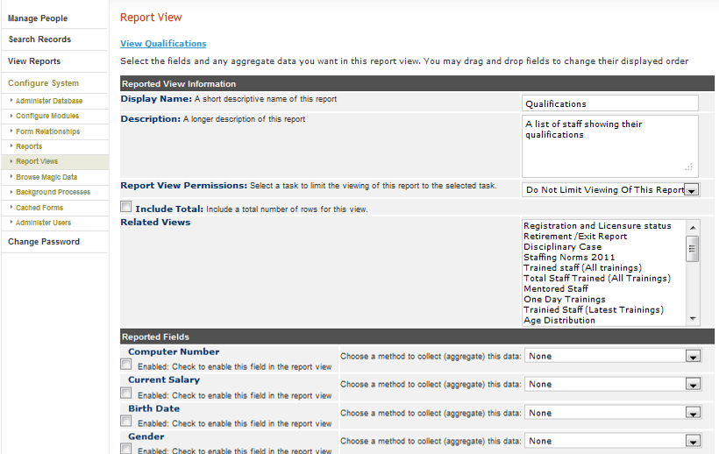

Click in the check box to enable the field

To change order of display of the fields on the report, point on the field name hold and drag to a desired order.

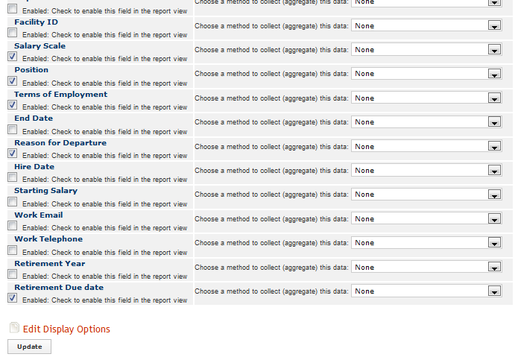

Check box that is enabled

After selecting all the desired fields and arrangement, Click **Update**

The pop up screen displaying the message ‘**successfully updated values’** click **Close**

# Administer Database

To ensure that standard data types such as countries, regions, districts, marital status, reasons for position changes, training types, program sponsors, facility and department names, and the like are enforced across the system, those standard data types must be created as lists. These lists are used to create selection menus that provide options for selection when adding records, jobs and positions.

Click **Configure System** and then click **Administer Database** to create and update standard lists of data for selection in system menus. Only the HR Manager and System Administrator can create data types.

Administer database is composed of several sections i.e. Geographic Information, Organization Lists, Employee Lists, Create Job Structure, Manage Positions, Create Training Information/Mentorship information, and Planning Information

**Geographic Information**

* [Country](http://10.42.43.1/iHRIS/4.0.22/kamwenge-manage/lists?type=country)
* [Region](http://10.42.43.1/iHRIS/4.0.22/kamwenge-manage/lists?type=region&field=country)
* [District](http://10.42.43.1/iHRIS/4.0.22/kamwenge-manage/lists?type=district&field=region)
* [Sub-County](http://10.42.43.1/iHRIS/4.0.22/kamwenge-manage/lists?type=county&field=district)
* [Currency](http://10.42.43.1/iHRIS/4.0.22/kamwenge-manage/lists?type=currency)

**Organization Lists**

* [Facility Type](http://10.42.43.1/iHRIS/4.0.22/kamwenge-manage/lists?type=facility_type)
* [Office/Facility](http://10.42.43.1/iHRIS/4.0.22/kamwenge-manage/lists?type=facility&field=location)
* [Department](http://10.42.43.1/iHRIS/4.0.22/kamwenge-manage/lists?type=department)
* [Registration Councils](http://10.42.43.1/iHRIS/4.0.22/kamwenge-manage/lists?type=council)

**Employee Lists**

* [Education Level](http://10.42.43.1/iHRIS/4.0.22/kamwenge-manage/lists?type=edu_type)
* [Qualification](http://10.42.43.1/iHRIS/4.0.22/kamwenge-manage/lists?type=degree&field=edu_type)
* [Language](http://10.42.43.1/iHRIS/4.0.22/kamwenge-manage/lists?type=language)
* [Competency Type](http://10.42.43.1/iHRIS/4.0.22/kamwenge-manage/lists?type=competency_type)
* [Competency](http://10.42.43.1/iHRIS/4.0.22/kamwenge-manage/lists?type=competency&field=competency_type)
* [Competency Evaluation](http://10.42.43.1/iHRIS/4.0.22/kamwenge-manage/lists?type=competency_evaluation)
* [Identification Type](http://10.42.43.1/iHRIS/4.0.22/kamwenge-manage/lists?type=id_type)
* [Benefit Type](http://10.42.43.1/iHRIS/4.0.22/kamwenge-manage/lists?type=benefit_type)
* [Marital Status](http://10.42.43.1/iHRIS/4.0.22/kamwenge-manage/lists?type=marital_status)
* [Reasons for Departure](http://10.42.43.1/iHRIS/4.0.22/kamwenge-manage/lists?type=pos_change_reason)
* [Terms of Employment](http://10.42.43.1/iHRIS/4.0.22/kamwenge-manage/lists?type=employment_terms)
* [Accident Type](http://10.42.43.1/iHRIS/4.0.22/kamwenge-manage/lists?type=accident_type)
* [Disciplinary Action Type](http://10.42.43.1/iHRIS/4.0.22/kamwenge-manage/lists?type=disciplinary_action_type)
* [Reason for Disciplinary Action](http://10.42.43.1/iHRIS/4.0.22/kamwenge-manage/lists?type=disciplinary_action_reason)

**Create Job Structure**

* [Cadres](http://10.42.43.1/iHRIS/4.0.22/kamwenge-manage/lists?type=cadre)
* [Salary Scale](http://10.42.43.1/iHRIS/4.0.22/kamwenge-manage/lists?type=salary_grade)
* [Jobs](http://10.42.43.1/iHRIS/4.0.22/kamwenge-manage/lists?type=job)

**Manage Positions**

* [Salary Sources](http://10.42.43.1/iHRIS/4.0.22/kamwenge-manage/lists?type=salary_source)
* [Positions (by Facility)](http://10.42.43.1/iHRIS/4.0.22/kamwenge-manage/lists?type=position&field=facility)

**Create Training Information/Mentorship information**

* [Training Type](http://10.42.43.1/iHRIS/4.0.22/kamwenge-manage/lists?type=baylor_training_type)
* [One Day Training Type](http://10.42.43.1/iHRIS/4.0.22/kamwenge-manage/lists?type=one_day_type)
* [Program Sponsor](http://10.42.43.1/iHRIS/4.0.22/kamwenge-manage/lists?type=baylor_program_sponsor)
* [Venue](http://10.42.43.1/iHRIS/4.0.22/kamwenge-manage/lists?type=venue&field=location)
* [Area of Mentorship](http://10.42.43.1/iHRIS/4.0.22/kamwenge-manage/lists?type=mentorship_area)

**Planning Information**

* [Establishment Type](http://10.42.43.1/iHRIS/4.0.22/kamwenge-manage/lists?type=establishment_type)
* [Establishment Period](http://10.42.43.1/iHRIS/4.0.22/kamwenge-manage/lists?type=establishment_period&field=establishment_type)
* [Establishments](http://10.42.43.1/iHRIS/4.0.22/kamwenge-manage/lists?type=establishment&field=establishment_period)

## Geographical Areas

## Add a Country

You will need to add at least one country to the system for selection whenever a geographical location is required. This should be the country where your organization's headquarters are located. In addition, you should add the names of all countries where employees are located or all nationalities you would like to track in the system.

Click **Configure System then click Administer Database.**   
Click on Country

The Country page opens, showing all Countries entered in the database. Either Click Add New Country or select an existing Country and click **Update This Information** to edit it.

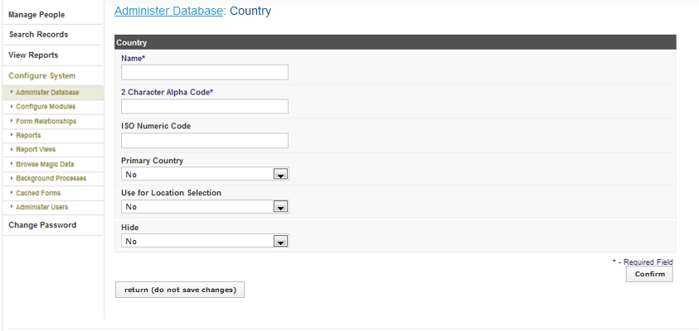

## Add a Region

A *region* is a major subdivision of a country. Region choices depend on which country is selected; only a region that is associated with a particular country can be chosen when that country is selected. For each country you have entered in the system, add at least one region.

Click **Configure System then click Administer Database.**   
Click on Region

The Region page opens, click on View to see all Regions entered in the database.

[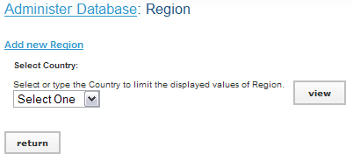](http://open.intrahealth.org/ihrismanual/file_addregion1.html)

Either Click Add New Region or select an existing Region and click **Update This Information** to edit it.

[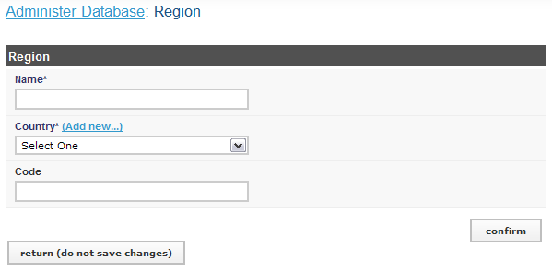](http://open.intrahealth.org/ihrismanual/file_addregion2.html)

## Add a District

A *district* is a subdivision of a region. In some locations, the district may be called the *state* or *province*. District choices depend on which country is selected; only a district that is associated with a particular country can be chosen when the country is selected. For each region you have entered in the system, add at least one district.

Click **Configure System then click Administer Database.**   
Click on District

The District page opens, click on View to see all Districts entered in the database.

[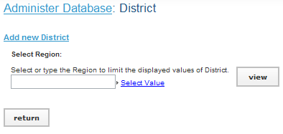](http://open.intrahealth.org/ihrismanual/file_adddistrict1.html)

Either Click Add New District or select an existing District and click **Update This Information** to edit it.

[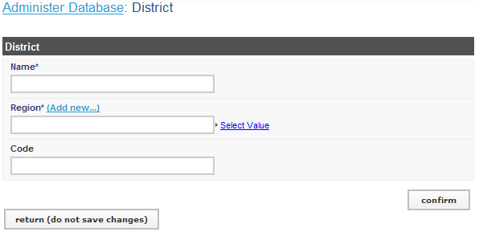](http://open.intrahealth.org/ihrismanual/file_adddistrict2.html)

Type the name of the **Region** or select the **Country** and then the **Region** in which the district is located.   
Enter a **Code** for the district (optional).   
Click Confirm and confirm that the information entered is correct. If it is not correct, click Edit to change it. If it is, click Save to save it.

## Add a County or Sub-county

A *county* is a smaller geographical division within a district. The term *county* corresponds to *sector* in some locations. Assigning counties is optional for this system. County choices depend on which district is selected; only a county that is associated with a particular district can be chosen after that district is selected. For any district entered in the system, you may add multiple counties.

Click **Configure System then click Administer Database.**   
Click on County

The County page opens, showing all Counties entered in the database. Either Click Add New County or select an existing County and click **Update This Information** to edit it.

[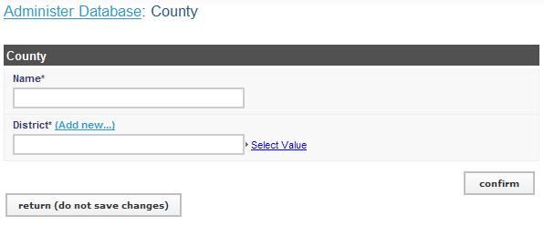](http://open.intrahealth.org/ihrismanual/file_addcounty1.html)

## Add a Currency

If your organization pays salaries or other payments in more than one currency, you should add each currency. The correct currency may then be selected when entering the salary or special payment. At least one currency should be added.

Click **Configure System then click Administer Database.**   
Click on Currency

The Currency page opens, showing all Currencies entered in the database.

[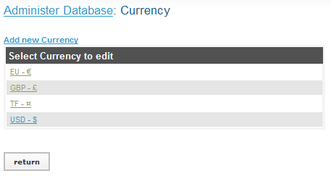](http://open.intrahealth.org/ihrismanual/file_addcurrency1.html)

Either Click Add New Currency or select an existing Currency and click **Update This Information** to edit it.

[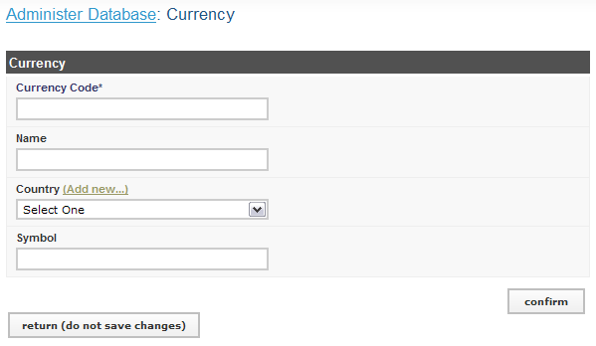](http://open.intrahealth.org/ihrismanual/file_addcurrency2.html)

The Currency form opens. Enter the **Currency Code**, an abbreviation that will identify the currency in selection menus.   
  
Enter the **Name** of the currency (optional).   
  
Select the **Country** for the currency (optional).   
  
Enter the **Symbol** for the currency; the symbol will also appear in selection menus (optional).   
  
Click Confirm and confirm that the information entered is correct. If it is not correct, click Edit to change it. If it is, click Save to save it.

## Organization Lists

### Add a Facility Type

The *facility type* classifies each office and facility in the organization for reporting and organizational purposes. Examples of facility types include Office, General Hospital, Health center IV, etc. Specify at least one facility type.

Click **Configure System then click Administer Database.**   
Click on Facility Type.

The Facility Type. page opens, showing all types entered in the database.

[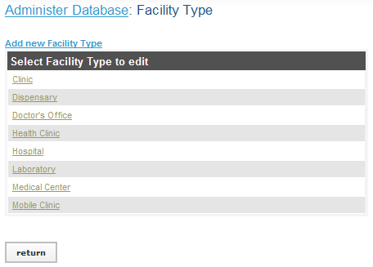](http://open.intrahealth.org/ihrismanual/file_facilitytype1.html)

Either Click Add New Facility Type or select an existing Facility Type and click **Update This Information** to edit it.

[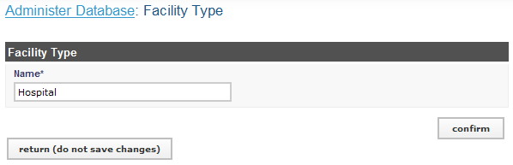](http://open.intrahealth.org/ihrismanual/file_facilitytype2.html)

The Facility Type form opens. Enter the **Name** of the facility type. Click Confirm and confirm that the name entered is correct. If it is not correct, click Edit to change it. If it is, click Save to save it.

### Add an Office or Facility Name

If your organization has multiple offices or facilities, you may add each one to the system in order to link positions to the offices or facilities where they are located. You may also update information about an office or facility if it changes. Enter at least one office or facility, preferably the location of your organization's headquarters.

Click on Facility

The Facility page opens, click on View to view all Facilities entered in the database.

[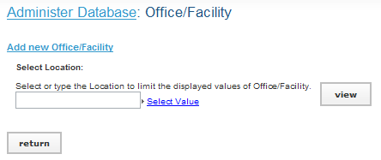](http://open.intrahealth.org/ihrismanual/file_offices1.html)

Either Click Add New Facility or select an existing Facility and click **Update This Information** to edit it.

[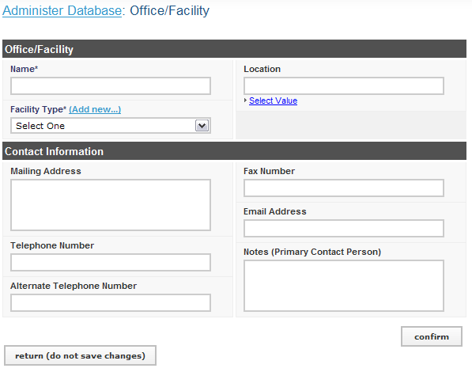](http://open.intrahealth.org/ihrismanual/file_offices2.html)

Select a **Facility Type** for the office or facility.   
  
Enter the **Contact Information** for the office or facility (optional).

Under **Location**, either type the name of the district where the office or facility is located, or click Select Value and select the Country, Region and District where the office or facility is located.   
  
Click Confirm and confirm that the information entered is correct. If it is not correct, click Edit to change it. If it is, click Save to save it.

### Add a Department

If any part of your organization is structured into departments, you may add them to the system and then link positions to their departments. Examples of departments include Finance, Health, Information Technology, Administration, and Human Resources. If your organization does not use departments, you may skip this step.

Click **Configure System then click Administer Database.**   
Click on Department

[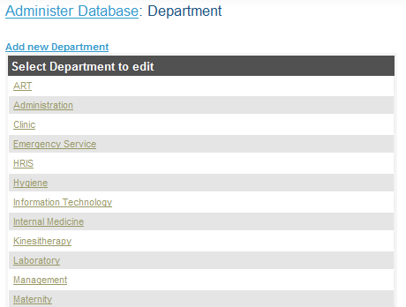](http://open.intrahealth.org/ihrismanual/file_departments1.html)

The Department page opens, showing all departments entered in the database. Either Click Add New Department or select an existing Department and click **Update This Information** to edit it

[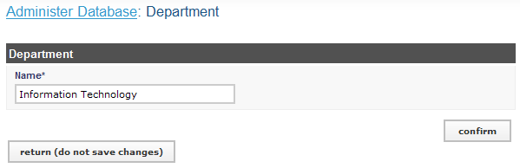](http://open.intrahealth.org/ihrismanual/file_departments2.html)

Enter the **Name** of the department. Click Confirm and confirm that the name entered is correct. If it is not correct, click Edit to change it. If it is, click Save to save it.

### Add a Registration Council

A *registration council* is the professional association or licensing board that registers health professionals, such as nurses and midwives council. If your organization needs to track these registrations or licenses for your employees, enter the name of at least one registration council for selection.

Click **Configure System then click Administer Database.**   
Click on Registration Council

[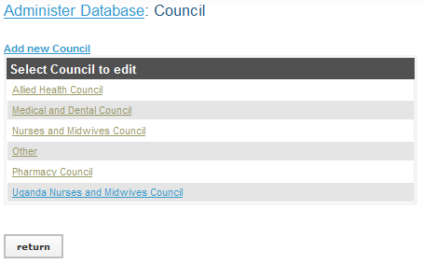](http://open.intrahealth.org/ihrismanual/file_councils1.html)

The Registration Council page opens, showing all Registration Councils entered in the database. Either Click Add New Registration Council or select an existing Registration Council and click **Update This Information** to edit it.

[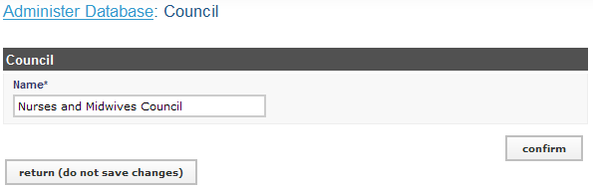](http://open.intrahealth.org/ihrismanual/file_councils2.html)

Enter the **Name** of the Registration Council. Click Confirm and confirm that the name entered is correct. If it is not correct, click Edit to change it. If it is, click Save to save it.

## Create Training Information/Mentorship information

### Add Training Type

Click **Configure System then click Administer Database.**   
Click on Training Type

The Training Type page opens, showing all Training Types entered in the database.

Either click Add New Training Type or select an existing training type and click Update This Information to edit it.

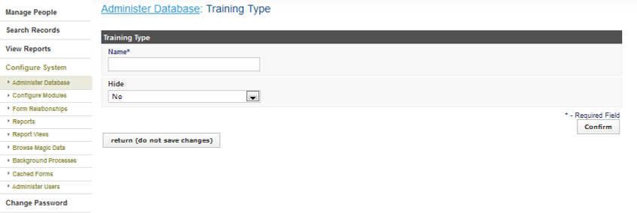

Add the training type Click confirm and click save

### Add One Training Type

Click **Configure System then click Administer Database.**   
Click on One Day Training Type

The One Day Training Type page opens, showing all One Day Training Types entered in the database. Either Click Add New One Day Training Type or select an existing one day training type and click **Update This Information** to edit it.

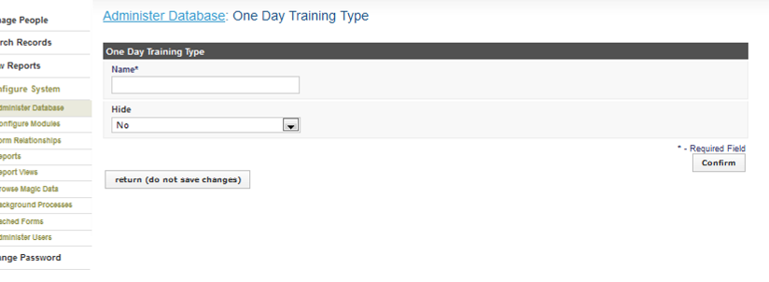

Add the one day training type Click confirm and click save

### Add Program Sponsor

Click **Configure System then click Administer Database.**   
Click on Program Sponsor

The Program Sponsor page opens, showing all Program Sponsors entered in the database. Either Click Add New Program Sponsor or select an existing program sponsor and click **Update This Information** to edit it.

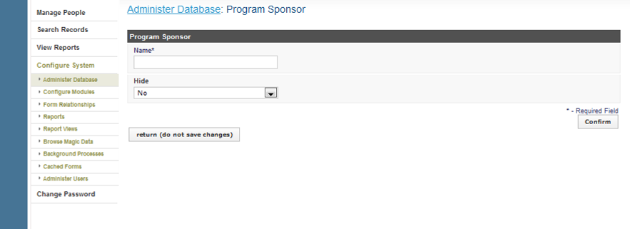

Add the program sponsor Click confirm and click save

### Add Venue

Click **Configure System then click Administer Database**   
Click on **Venue**

The Venue page opens, click view to show all Venues entered in the database. Either Click Add New Venue or select a venue and click **Update This Information** to edit it.

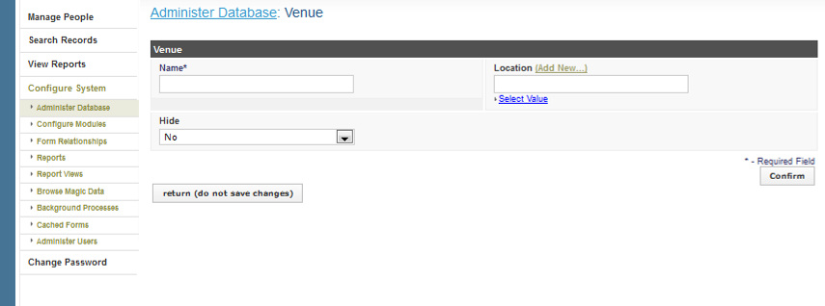

Add the venue, select the location, Click confirm and click save

### Add Area of Mentorship

Click **Configure System** then click **Administer Database**   
Click on Area of Mentorship

The Area of Mentorship page opens, showing all Area of Mentorships entered in the database. Either Click Add New Area of Mentorship or select an area of mentorship and click **Update This Information** to edit it.

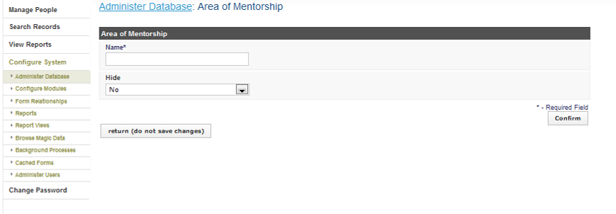

Add the area of mentorship Click confirm and click save

## Add an Education Type/Level

The *education type/level* classifies a type of educational institution that issues degrees/certification. Education types are selected when entering a person's educational history.

Click **Configure System** then click **Administer Database**   
Click on **Education Type/Level**

The Education Type/Level page opens, showing all Education Types/Levels entered in the database. Either Click **Add Education Type/Level** or select an Education Type/Level and click **Update This Information** to edit it.

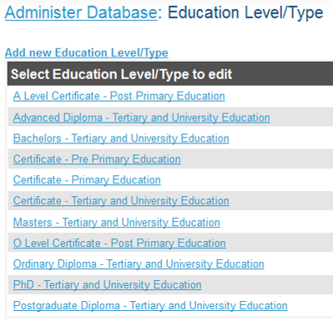

## Add Qualification

After adding an education level/type, you will need to add one or more kinds of qualification for that level/type. The qualification will be selected when entering the educational history for a person into the system. Examples of qualification include: UCE, UACE, Bachelor's degree in Computer science, and Master's degree in Public Health.

Click **Configure System** then click **Administer Database**   
Click on **Qualification**

The qualification page opens, click view to show all qualifications entered in the database. Either Click **Add Qualification** or select a qualification and click **Update This Information** to edit it.

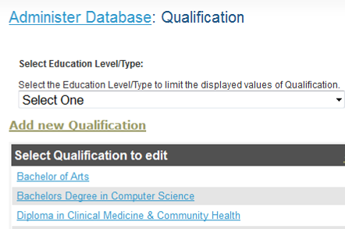

## Add a Language

If you want to track employee proficiency in speaking, reading and writing foreign languages, each language must be added to the system to be selected when adding the employee's qualifications.

Click **Configure System** then click **Administer Database**   
Click on **Language**

The Language page opens, showing all Languages entered in the database.

[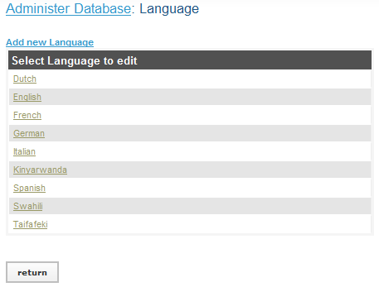](http://open.intrahealth.org/ihrismanual/file_languages1.html)

Either Click **Language** or select a **Language** and click **Update This Information** to edit it.

[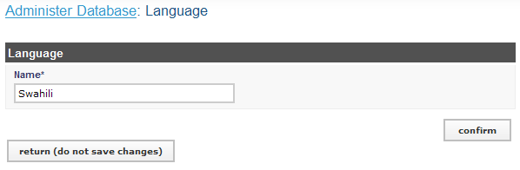](http://open.intrahealth.org/ihrismanual/file_languages2.html)

Click Confirm and confirm that the name entered is correct. If it is not correct, click Edit to change it. If it is, click Save to save it.

## Add a Competency Type

A *competency type* is a broad category for organizing competencies, or skills in which employees have been assessed as competent. Examples of competency types include Computer Skills, Client Interaction and Diagnostics. Competency types combined with competencies comprise your organization's competency model.

Click **Configure System** then click **Administer Database**   
Click on **Competency Type**

The **Competency Type** page opens, showing all Competency Types entered in the database.

[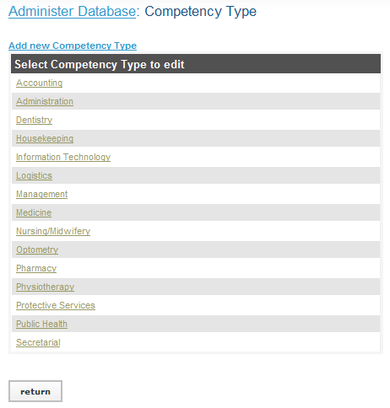](http://open.intrahealth.org/ihrismanual/file_competencytype1.html)

Either Click **Add Competency Type** or select an Competency Type and click **Update This Information** to edit it.

[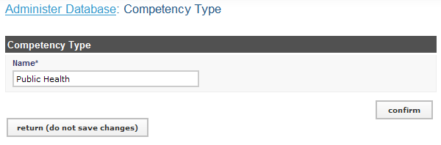](http://open.intrahealth.org/ihrismanual/file_competencytype2.html)

Enter the **Name** of the competency type. Click Confirm and confirm that the name entered is correct. If it is not correct, click Edit to

## Add a Competency

After adding a competency type, add one or more *competencies*--skills or qualifications in which an employee has been assessed as competent--grouped under that competency type. For example, for the competency type Computer Skills, specific competencies could include Data Entry, Software Use and Document Formatting. The set of competencies and competency types comprise your organization's competency model. When an employee has been assessed as having a particular competency, that competency can be added to the employee's record. Competencies may also be earned by completing training courses.

Click **Configure System** then click **Administer Database**   
Click on **Competency**

The **Competency** page opens, showing all **Competencies** entered in the database.

[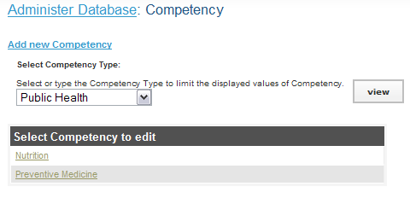](http://open.intrahealth.org/ihrismanual/file_competency1.html)

Either Click **Add Competency** or select a Competency **Update This Information** to edit it.

[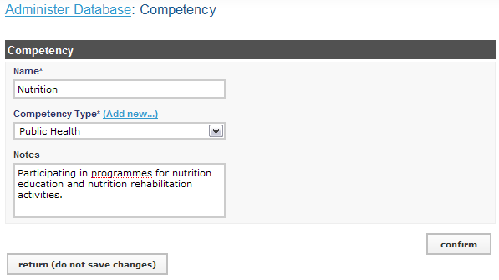](http://open.intrahealth.org/ihrismanual/file_competency2.html)

Enter a **Name** for the competency.   
Select the **Competency Type** for the competency.   
Enter any **Notes** about the competency (optional).   
  
Click Confirm and confirm that the name entered is correct. If it is not correct, click Edit to change it. If it is, click Save to save it.

## Add a Competency Evaluation

If you want to assess an employee in a particular competency, each evaluation option must be added for selection when making the assessment. For example, you might enter "Competent," "Not Competent" and "Not Assessed" as options to select for the evaluation.

Click **Configure System** then click **Administer Database**   
Click on Competency Evaluation

[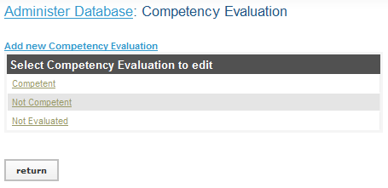](http://open.intrahealth.org/ihrismanual/file_competencyevaluation1.html)

The Competency Evaluation page opens, showing all Competency Evaluations entered in the database.

Either Click **Add** Competency Evaluation or select a Competency Evaluation and click **Update This Information** to edit it.

[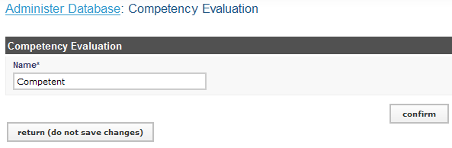](http://open.intrahealth.org/ihrismanual/file_competencyevaluation2.html)

Enter the **Name** of the competency evaluation. Click Confirm and confirm that the name entered is correct. If it is not correct, click Edit to change it. If it is, click Save to save it.

## Add an Identification Type

The *identification type* classifies a type of identification, or non-changing information, used to identify an employee or applicant. Examples of identification types include File number, computer number, Passport, Social Security Number and National Health Insurance Card.

Click **Configure System** then click **Administer Database**   
Click on Identification Type

The Identification Type page opens, showing all Identification Types entered in the database.

[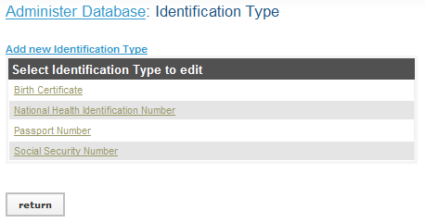](http://open.intrahealth.org/ihrismanual/file_identification1.html)

Either Click **Add** Identification Type or select an Identification Type and click **Update This Information** to edit it.

[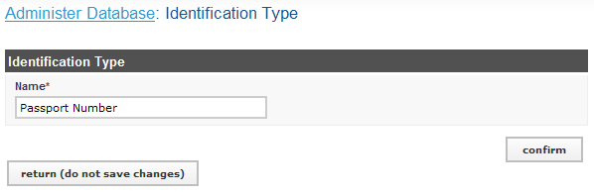](http://open.intrahealth.org/ihrismanual/file_identification2.html)

Enter the **Name** of the identification type. Click Confirm and confirm that the name entered is correct. If it is not correct, click Edit to change it. If it is, click Save to save it.

## Add a Benefit/Allowance Type

The *benefit type* classifies a type of benefit or special payment to an employee. Examples of benefit types include Allowance, Travel Advance and Bonus.

Click **Configure System** then click **Administer Database**   
Click on Benefit/Allowance Type

The Benefit/Allowance Type page opens, showing all Benefit/Allowance Types entered in the database.

[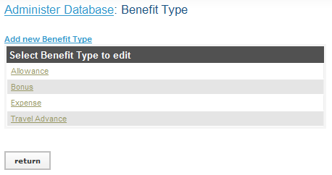](http://open.intrahealth.org/ihrismanual/file_benefit1.html)

Either Click **Add** Benefit/Allowance Type or select a Benefit/Allowance Type and click **Update This Information** to edit it.

[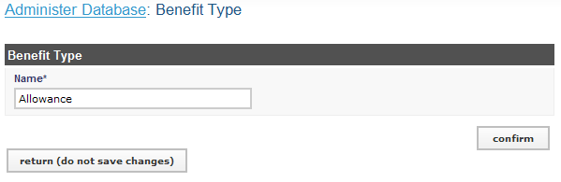](http://open.intrahealth.org/ihrismanual/file_benefit2.html)

Click Confirm and confirm that the name entered is correct. If it is not correct, click Edit to change it. If it is, click Save to save it.

## Add a Marital Status

*Marital status* is used to identify employees' legal status. Examples of marital status include Single, Married, Divorced and Widowed.

Click **Configure System** then click **Administer Database**   
Click on Marital Status

The Marital Status page opens, showing all Marital Status entered in the database.

[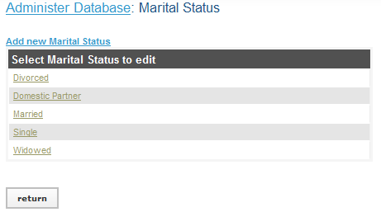](http://open.intrahealth.org/ihrismanual/file_maritalstatus1.html)

Either Click **Add** Marital Status or select a Marital Status and click **Update This Information** to edit it.

[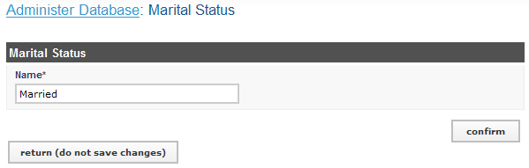](http://open.intrahealth.org/ihrismanual/file_maritalstatus2.html)

Enter the **Name** of the marital status. Click Confirm and confirm that the name entered is correct. If it is not correct, click Edit to change it. If it is, click Save to save it.

## Add a Reason for Departure

*Reasons for departure* are used to classify the reasons why an employee has left the employment of the organization or changed positions. Examples of reasons for departure include Promotion, Termination, Layoff, Illness, Death and Out Migration.

Click **Configure System** then click **Administer Database**   
Click on Reason for Departure

The Reason for Departure page opens, showing all Reasons for Departure entered in the database. Either Click **Add** Reason for Departure or select a Reason for Departure and click **Update This Information** to edit it.

## Create a Job Structure

iHRIS Manage enables HR Managers and Staff to design and manage a job structure for the organization. Jobs may be categorized by health professional cadre, job classification and salary grade, and may be assigned standard titles, codes and job descriptions. Click Administer Database under Configure System to create the job structure, add new positions that may be filled by employees or applicants and manage existing positions.

### Add Cadres

A *cadre* is a broad category of health workers characterized by the specific training, certification or other qualifications required to practice or be licensed in that field. Examples of cadres include Nurse, Physician and Pharmacist. Each job can be linked to one cadre for reporting purposes. You may add new cadres or edit any cadre that was previously added. Only the HR Manager or System Administrator can update the cadres.

Click **Configure System** then click **Administer Database**   
Click on Cadres

[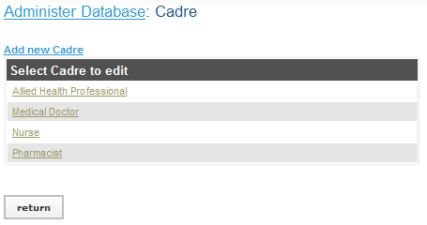](http://open.intrahealth.org/ihrismanual/file_cadres1.html)

The Cadres page opens, showing all Cadres entered in the database. Either Click **Add** Cadre or select a Cadre and click **Update This Information** to edit it.

[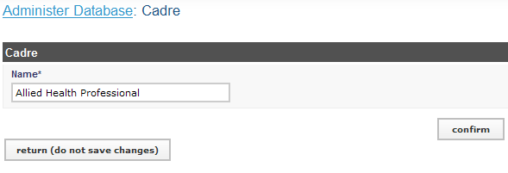](http://open.intrahealth.org/ihrismanual/file_cadres2.html)

Click Confirm and confirm that the name entered is correct. If it is not correct, click Edit to change it. If it is, click Save to save it.

### Add Job Classifications

A *job classification* is a broad category used to organize jobs. Each job can be optionally linked to one job classification for organization and reporting purposes. Examples of job classifications include Manager, Professional, Technician, Service Worker and Clerical Worker.

You should add all the job classifications in use in your organization to the system; you may also edit any job classification previously added. If your organization does not use job classifications to organize jobs, you can skip this step. Only the HR Manager or System Administrator can update job classifications.

Click **Configure System** then click **Administer Database**   
Click on Job Classification

The Job Classifications page opens, showing all Job Classifications entered in the database.

[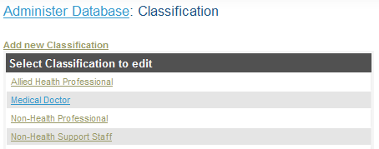](http://open.intrahealth.org/ihrismanual/file_classification1.html)

Either Click **Add** Job Classifications or select a Job Classification and click **Update This Information** to edit it.

[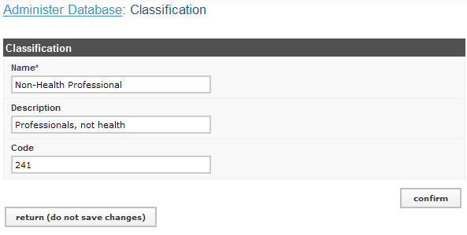](http://open.intrahealth.org/ihrismanual/file_classification2.html)

Enter the **Name** of the job classification.   
Enter a brief **Description** of the job classification (optional).   
Enter a **Code** for the job classification (optional).   
  
Click Confirm and confirm that the name entered is correct. If it is not correct, click Edit to change it. If it is, click Save to save it.

### Add Salary Scale/Grades

If your organization defines *salary scale/grades* or bands -- pay ranges for one or more jobs -- add those grades to the system. (If your organization does not define salary grades, you can skip this step.) A job can then be linked to its corresponding salary grade. Only the HR Manager or System Administrator can add or edit salary grades.

Click **Configure System** then click **Administer Database**   
Click on Salary Scale/Grades

The Salary Scale/Grades page opens, showing all Salary Scale/Grades entered in the database.

[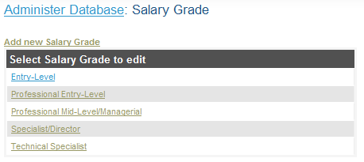](http://open.intrahealth.org/ihrismanual/file_salarygrade1.html)

Either Click **Add** Salary Scale/Grades or select an Salary Scale/Grades and click **Update This Information** to edit it.

[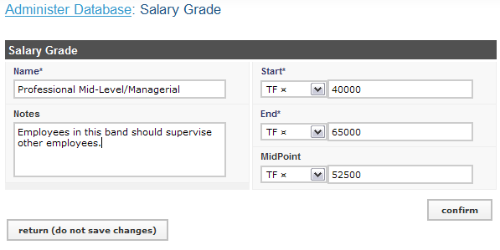](http://open.intrahealth.org/ihrismanual/file_salarygrade2.html)

The Salary Grades form opens.   
Enter the **Name**, or identifier, of the salary grade.   
Enter any **Notes** to record about the salary grade (optional).   
Select a **Currency** for the starting salary and enter the amount of the **Start** salary (the lowest salary in the band).   
Select a **Currency** for the ending salary and enter the amount of the **End** salary (the highest salary in the band).

Select a **Currency** for the midpoint salary and enter the amount of the **Midpoint** salary (the midpoint is the average salary in the band offered to a new hire, which may or may not be the equivalent of the true average of the starting and ending salaries). This is optional.  
  
Click Confirm and confirm that the name entered is correct. If it is not correct, click Edit to change it. If it is, click Save to save it.

### Add Jobs

A *job* is a general set of qualifications, duties and responsibilities as specified in a job description. Each job has a unique job code and may be linked to a cadre, job classification and salary grade.

There may be multiple instances of the same job within an organization. Each of these instances is filled by one employee and is referred to as a *position*. Before a position can be created in the system, its generic job must be added. After creating a generic job, it can be reused as needed for multiple positions that perform the same general duties. For example, a Clinical Nurse, Pediatric Nurse and Intensive Care Nurse may all be positions with the same generic job of Nurse. Only the HR Manager or System Administrator can add or edit jobs.

Click **Configure System** then click **Administer Database**   
Click on Jobs

The Jobs page opens, showing all Jobs entered in the database.

[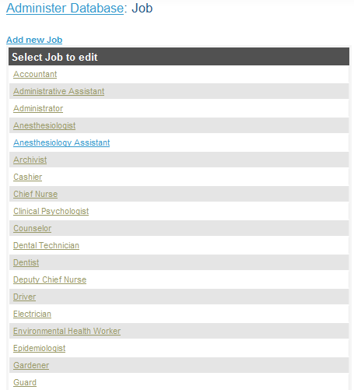](http://open.intrahealth.org/ihrismanual/file_job1.html)

Either Click **Add** Jobs or select a Job and click **Update This Information** to edit it.

[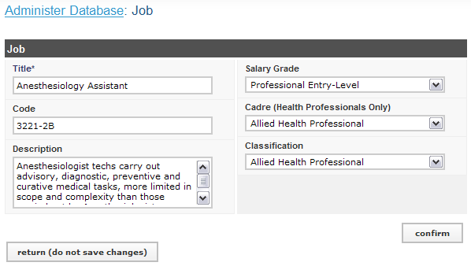](http://open.intrahealth.org/ihrismanual/file_job2.html)

The Job form opens.   
  
Enter a **Title** for the job.   
Enter a **Code** for the job (optional).   
Enter a **Description** for the job (optional).  
Select the **Salary Grade** for the job (optional).   
Select the **Cadre** for the job (optional). Only select a cadre for health professional jobs.   
Select the **Classification** for the job (optional).   
  
Click Confirm and confirm that the name entered is correct. If it is not correct, click Edit to change it. If it is, click Save to save it.

## Administer Positions

### Add Salary Sources

If your organization tracks multiple monetary sources of salaries and/or special payments, add those to the system so the source can be linked to a salary or special payment. Only the HR Manager or System Administrator can add or edit salary sources.

Click **Configure System** then click **Administer Database**   
Click on Salary Sources

The Salary Sources page opens, showing all Salary Sources entered in the database.

[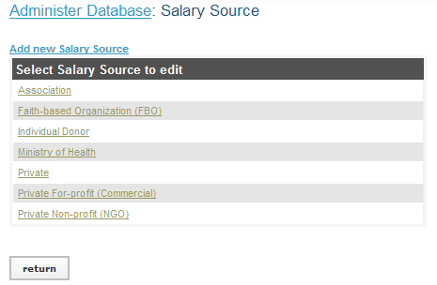](http://open.intrahealth.org/ihrismanual/file_salarysource1.html)

Either Click **Add** Salary Sources or select a Salary Sources and click **Update This Information** to edit it.

[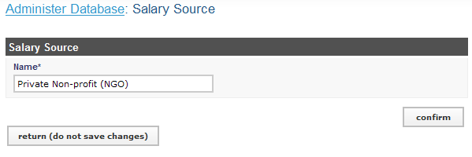](http://open.intrahealth.org/ihrismanual/file_salarysource2.html)

The Salary Source form opens. Enter the **Name** of the salary source. Click Confirm and confirm that the name entered is correct. If it is not correct, click Edit to change it. If it is, click Save to save it.

### Add Position Types

To classify positions by a category or type, add those position types to the system. Examples of position types include Permanent, Temporary, Contract, Consultant, Part-time and the like. Only the HR Manager or System Administrator can add or edit position types.

Click **Configure System** then click **Administer Database**   
Click on Position Types

The Position Types page opens, showing all Position Types entered in the database.

[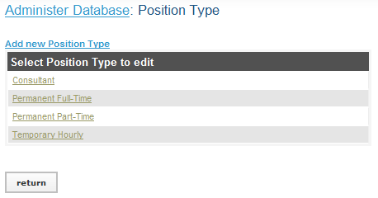](http://open.intrahealth.org/ihrismanual/file_positiontype1.html)

Either Click **Add** Position Types or select an Position Types and click **Update This Information** to edit it.

[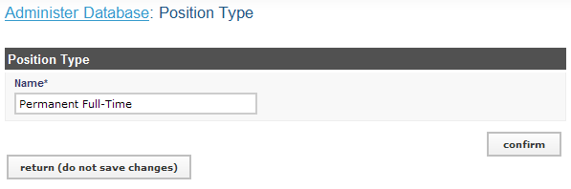](http://open.intrahealth.org/ihrismanual/file_positiontype2.html)

Enter the **Name** of the position type. Click Confirm and confirm that the name entered is correct. If it is not correct, click Edit to change it. If it is, click Save to save it.

### Add Positions

Adding a position creates a new position in the organization that a single employee will fill. The position must be created before it can be assigned to an existing employee or applications can be accepted for the position. A position that is not linked to an employee but for which you intend to hire someone to fill it is called an *open position*. A position that is not linked to an employee and for which you are not intending to hire someone is called a *discontinued position*. A position that is filled by an employee is called a *closed position*. Either an HR Staff person or an HR Manager can add a new position or update an existing position.

Click **Configure System** then click **Administer Database**   
Click on Positions

The Positions page opens, click view to show all Positions entered in the database.

[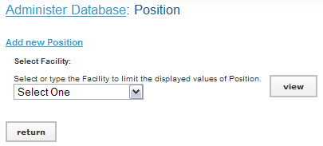](http://open.intrahealth.org/ihrismanual/file_position1.html)

Either Click **Add** Positions or select a Position and click **Update This Information** to edit it.

[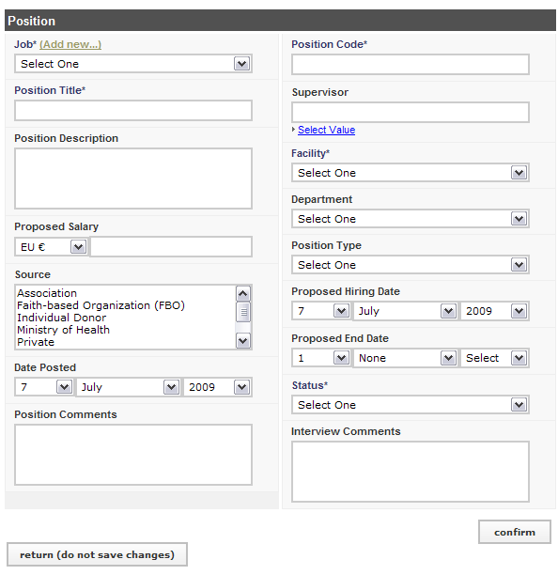](http://open.intrahealth.org/ihrismanual/file_position2.html)

Select the **Job** for the new position.   
Enter the **Position Title** (this may be the same as the job title).   
Enter a **Position Description** as an addendum to the job description (optional).   
  
Select a **Currency** for the salary and enter the **Proposed Salary** amount for the position; this amount will be changed to the actual salary when the position is filled (optional).   
  
If there are one or more salary sources to track for the position, select them in the **Source** box; to select more than one salary source, hold down the CTRL key while clicking the name of each salary source (optional).   
  
Today's date displays for the **Date Posted**, the date the position was opened. If this is incorrect, change the date.   
  
Enter any comments or notes about the position in the **Position Comments** box (optional).   
  
Enter the **Position Code**.   
  
Either type or select the code and title of the position that will supervise this position under **Supervisor** (optional).   
  
Select the office or facility where the position is located in the **Facility** menu.   
  
Select the **Department** where the position is located (optional).   
  
Select the **Position Type** (optional).   
  
Select the **Proposed Hiring Date** for the position (optional).   
  
If the position is short-term, select the **Proposed End Date** for the position (optional).   
  
Select the **Status** of the position: Open or Discontinued. Select *Open* if you want the position to be available for assignment to an employee.

If an interview has been held for the position, enter any comments or notes about it in the **Interview Comments** box (optional).   
  
Click Confirm and confirm that the name entered is correct. If it is not correct, click Edit to change it. If it is, click Save to save it.

### Edit a Position

Once a position has been created in the system, an HR Staff person or an HR Manager can change any of the information for the position.

Click **Configure System** then click **Administer Database**   
Click on select Positions (by Facility) add or edit a position based on the facility where it is located or select Positions (by Status) to add or edit a position based on its status as open, closed or discontinued.

[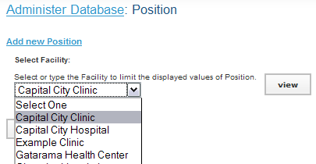](http://open.intrahealth.org/ihrismanual/file_position3.html)

The Position page opens. If you chose Positions (by Facility), select the name of the facility where the position is located from the **Facility** menu. If you chose Positions (by Status), select the status of the position from the **Status** menu. Click the View button to display all the positions entered for that facility or status.

[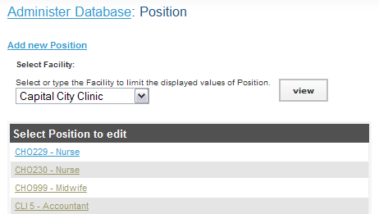](http://open.intrahealth.org/ihrismanual/file_position4.html)

A list of positions already entered in the database appears. Click the name of the position to edit.

The position information displays. Click Update This Information

[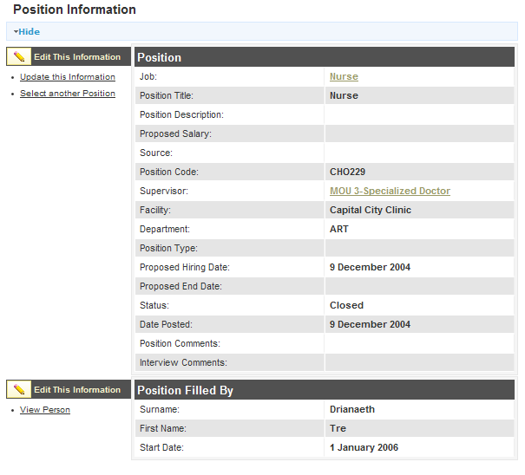](http://open.intrahealth.org/ihrismanual/file_position5.html)

The Position form opens, showing the position information that was previously entered. Change any field.   
  
Click Confirm and confirm that the changed information is correct. If it is not correct, click Edit to change it. If it is, click Save to save it.

### Discontinue a Position

If a position is no longer needed and is not filled by an employee, it can be discontinued. This will prevent the position from displaying in open position lists. The position can be re-opened at any time. Either an HR Staff person or an HR Manager can discontinue a position.

Click **Configure System** then click **Administer Database**   
Click on Positions (by Status).

The Position page opens. Select Open from the **Status** menu and click the View button. All of the open positions will display. Click the name of the position to edit.

[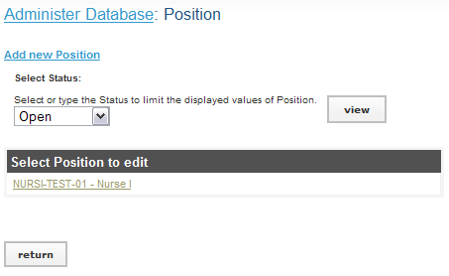](http://open.intrahealth.org/ihrismanual/file_position6.html)

The position information displays. Click Discontinue This Position to mark the position as discontinued

[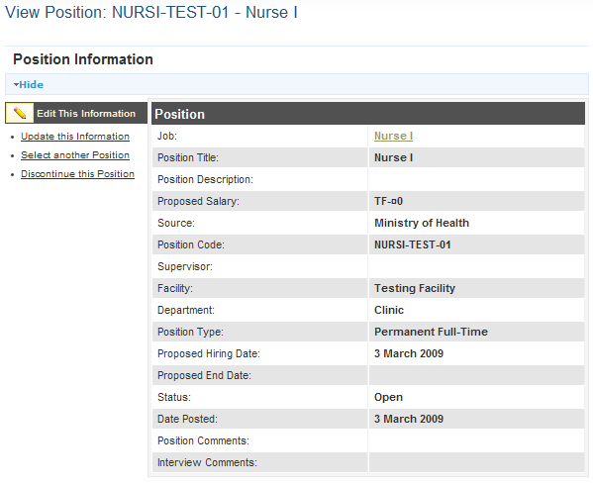](http://open.intrahealth.org/ihrismanual/file_position7.html)

To re-open a discontinued position, repeat the steps above but select Discontinued from the **Status** menu. Then click Open This Position beside the position information.

# HRIS Frequently asked Questions

1. Who owns integrated Human Resource Uganda Information System (iHRIS)?  
   HRIS is a system that is owned by the government of the Republic of Uganda.
2. Differences between IPPS and HRIS

IPPS (Integrated Payroll and Personal System) is payroll system for the government of Uganda while HRIS is a day to day human resource management for the health workforce.

1. Why are we using both IPPS and HRIS to capture the same information on a Health worker?

Currently, both systems are capturing information on health worker. However, with time IPPS will be exporting data on payroll to HRIS on a monthly and HRIS informing IPPS who has joined and who need to be added to the payroll.

1. Differences between HMIS and HRIS

HRIS is an information management tool designed specifically for managing human resources in the sector while HMIS is an aggregate of all health management information systems within the health sector. HRIS is a sub system that contributes to HMIS like other sub systems e.g. LMIS, DHIS.

1. Differences between DHIS and HRIS

DHIS is an information management tool designed specifically for aggregating patient records in the sector while HRIS is designed to manage human resources.

1. Differences between OPEN MRS and HRIS

OPEN MRS is an information system designed specifically for health facility management while HRIS is designed to manage human resources.

1. How do I change someone’s position information,
2. If he/she has been transferred within the same organization?

**First create the new position in that facility where the person has been transferred to**

Click on Configure system 🡪 Click on Administer database🡪Click on position by facility🡪

Click on Add New Position🡪 Select the new job of the person🡪 If the position name is different from the job then change it 🡪 Select the facility of the person🡪Select the department of the person🡪 Click on confirm and save

**Second we search for the person and record the transfer**

Click on search records🡪Click on search people🡪Type the person’s name and click search🡪 Click on the person’s name in the report to open his/her page🡪Click on Position information on the left menu or scroll down to position information🡪Click on change position, 🡪Select the new position🡪 Fill in the salary, Terms of employment and DSC minute if known🡪 Choose a reason for transfer🡪 Select what happens to the status of the current position 🡪Click on confirm and save

1. If he/she has left the organization’s service?

Click on search records🡪Click on search people🡪Type the person’s name and click search🡪 Click on the person’s name in the report to open his/her page🡪Scroll down to position information 🡪 Click on record a departure, 🡪 Select what happens to the status of the current position 🡪 Fill in the end date🡪 Choose a reason for departure🡪Click on confirm and save.

1. How do I assign a position for a new person in the service?

**First create the new position in that facility where the person has been posted**

Click on Configure system 🡪 Click on Administer database🡪 Click on position by facility 🡪

Click on Add New Position🡪 Select the new job of the person 🡪 If the position name is different from the job then change it🡪Select the facility of the person🡪Select the department of the person🡪 Click on confirm and save

**Second we search for the person to assign the position**

Click on search records🡪Click on search people🡪Type the person’s name and click search🡪 Click on the person’s name in the report to open his/her page🡪Scroll down to position information - Click on record a departure 🡪 Select what happens to the status of the current position - Fill in the end date🡪Choose a reason for departure🡪Click on confirm and save

1. What happens to the old positions when people change, transfer or depart

**There are three options that can happen to any position**

Open - Meaning it’s free, it’s in the system and no one is occupying it

Closed - Meaning it’s taken up by someone

Discontinued – Meaning it has been eliminated from the staffing norms/establishment.

When a position is left, by default the position become open, but one can decide to discontinue during the process when you are changing position. If it stays open then when a new employee comes into service we do not have to create it again.

**To view open positions:** Click on view reports🡪Click on position reports🡪 On the filters down select open and click on Apply limits.

1. How do I populate (add fields in) the drop down menus?

Click on Configure system🡪Click on Administer database (There is a list of all the fields in the drop down menus) - Click on the one you want to populate 🡪Click on Add New …🡪Enter the required fields🡪Click on confirm and save

1. How do I add a new person in the system?

Click on Manage People🡪Click on Add Person🡪Fill in the first individual information🡪Click on confirm and save. Click on Add Demographic information which is tab🡪Fill in the required fields🡪Click on confirm and save. Before you click on set position make sure you first create it.

After creating the position then assign it to the person. Then add all the necessary information on the person’s page

1. Can the system work without internet?

Yes, the system can work without internet.

The system can run on a computer that is not connected to internet.

It can also be access from several offices within the building through the LAN with or without internet.

HRIS can also be accessed globally through the internet as while as send updates to the MOH server on a weekly basis

1. How is the system backed up and where is it done?

The system does an automatic backup on the local computer and sends a copy to the MOH server on a weekly basis.

1. How do I resize my photo?  
   Go to the folder where your photo is stored, right click on the photo, select resize image, choose the option of custom and enter the standard size of passport photo i.e. 200 (height) by 150 (width). Then proceed to update the photo section of person’s information with the resized photo.
2. Deleting records  
   This function is currently reserved for advanced systems administrator and is subject to approval by PPO.
3. What to put in comments and notes sections  
   Any information deemed to be useful in relation to that section and is not captured by any of the field designed in HRIS.
4. Why do I continue to see a person in the system when I recorded a departure?  
   When you record a departure, the person’s record is not permanently deleted from the database but is deactivated from the staff list. This simply means that the person’s record is removed from the active staff list. To view active staff, go to “***view report***” and select “***staff list***”.

However, the person’s record will continue to be available in the system and can be viewed through searching the database via “***search records***”.

1. Search records and staff lists gives a different number  
   Numbers on staff list and search list will vary because of the explanation given in the question 17.
2. How do I know the records entered on a particular day  
   To get information on record entered on a particular day i.e. not more than one week, click on search records, select recent changes and choose the option of your interest.
3. How can I tell who accessed the system and what they did  
   The system keeps a log of all operations and it’s accessible by the system administrator

**THE FUTURE WITH HRIS**

**BEFORE HRIS AFTER HRIS**

 